git init 🡪 create brand new repo on computer

git clone 🡪 copy existing repos from somewhere else to your PC

git status 🡪 check status

git log 🡪 shows existing commits

--oneline 🡪compact version

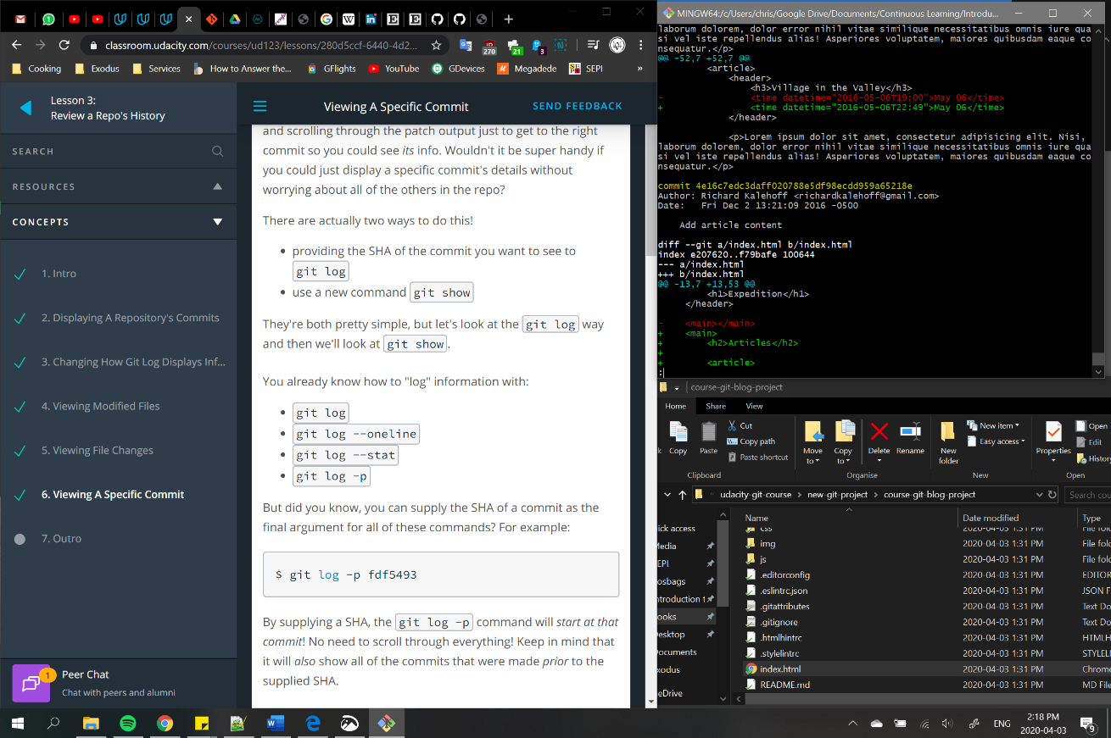 --stat 🡪 displays file changes

--patch or -p 🡪 shows the actual changes into the files

-w 🡪 whitespaces are ignored

--decorate 🡪 shows additional info

git show 🡪 displays info about the given commit

add SHA 🡪 it will show info about just that commit

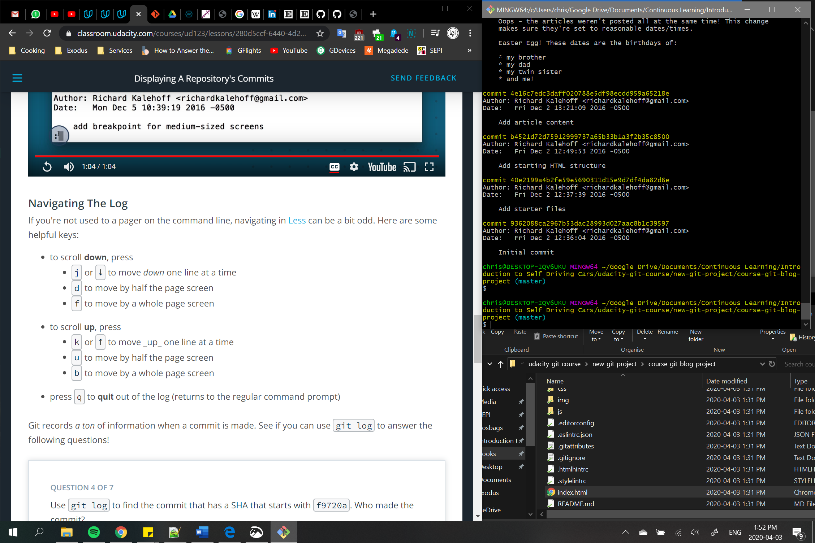

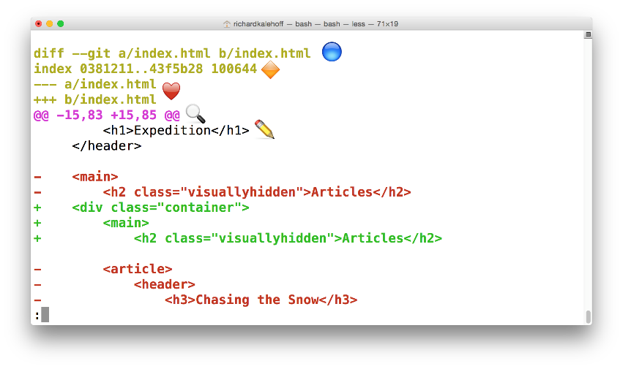 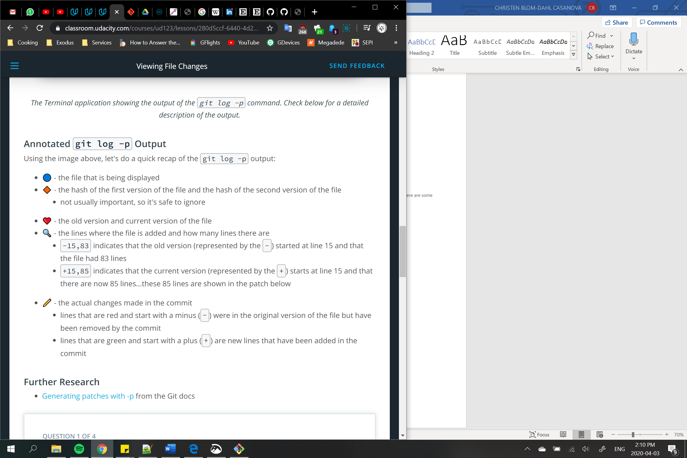

git add 🡪 add files from the working directory to the staging index

. 🡪 in order to add everything

git commit 🡪 take files from staging index and save them in the repository

if vim editor: fill first line with commit comment -> ESC -> :x

-m “comment” -> bypasses the editor

-a -m “comment” -> to remove also deleted files in remote repo

Comments should say what the change is.  
 If you need to explain why, add an empty line in the vim editor and then the explanatory text

git diff 🡪 see changes that have been made but haven't been committed, yet

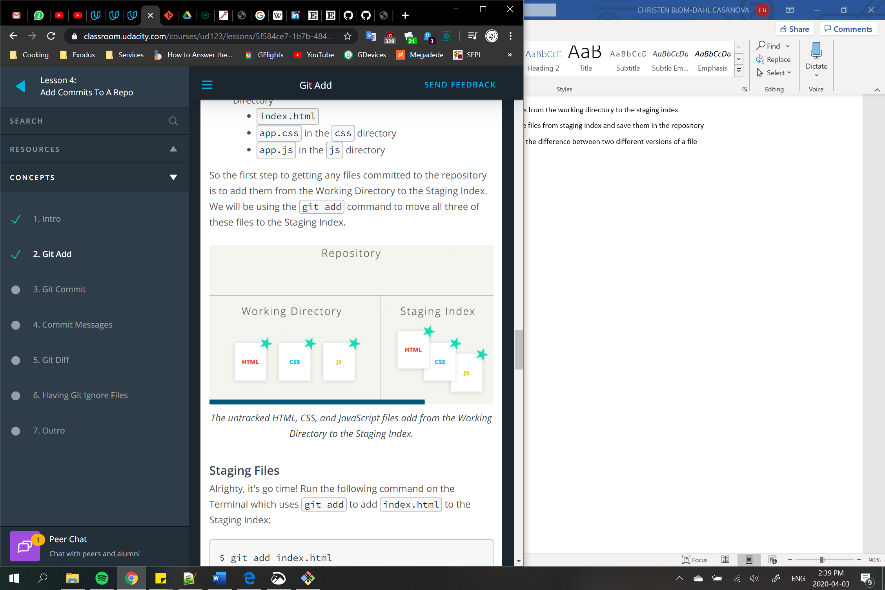 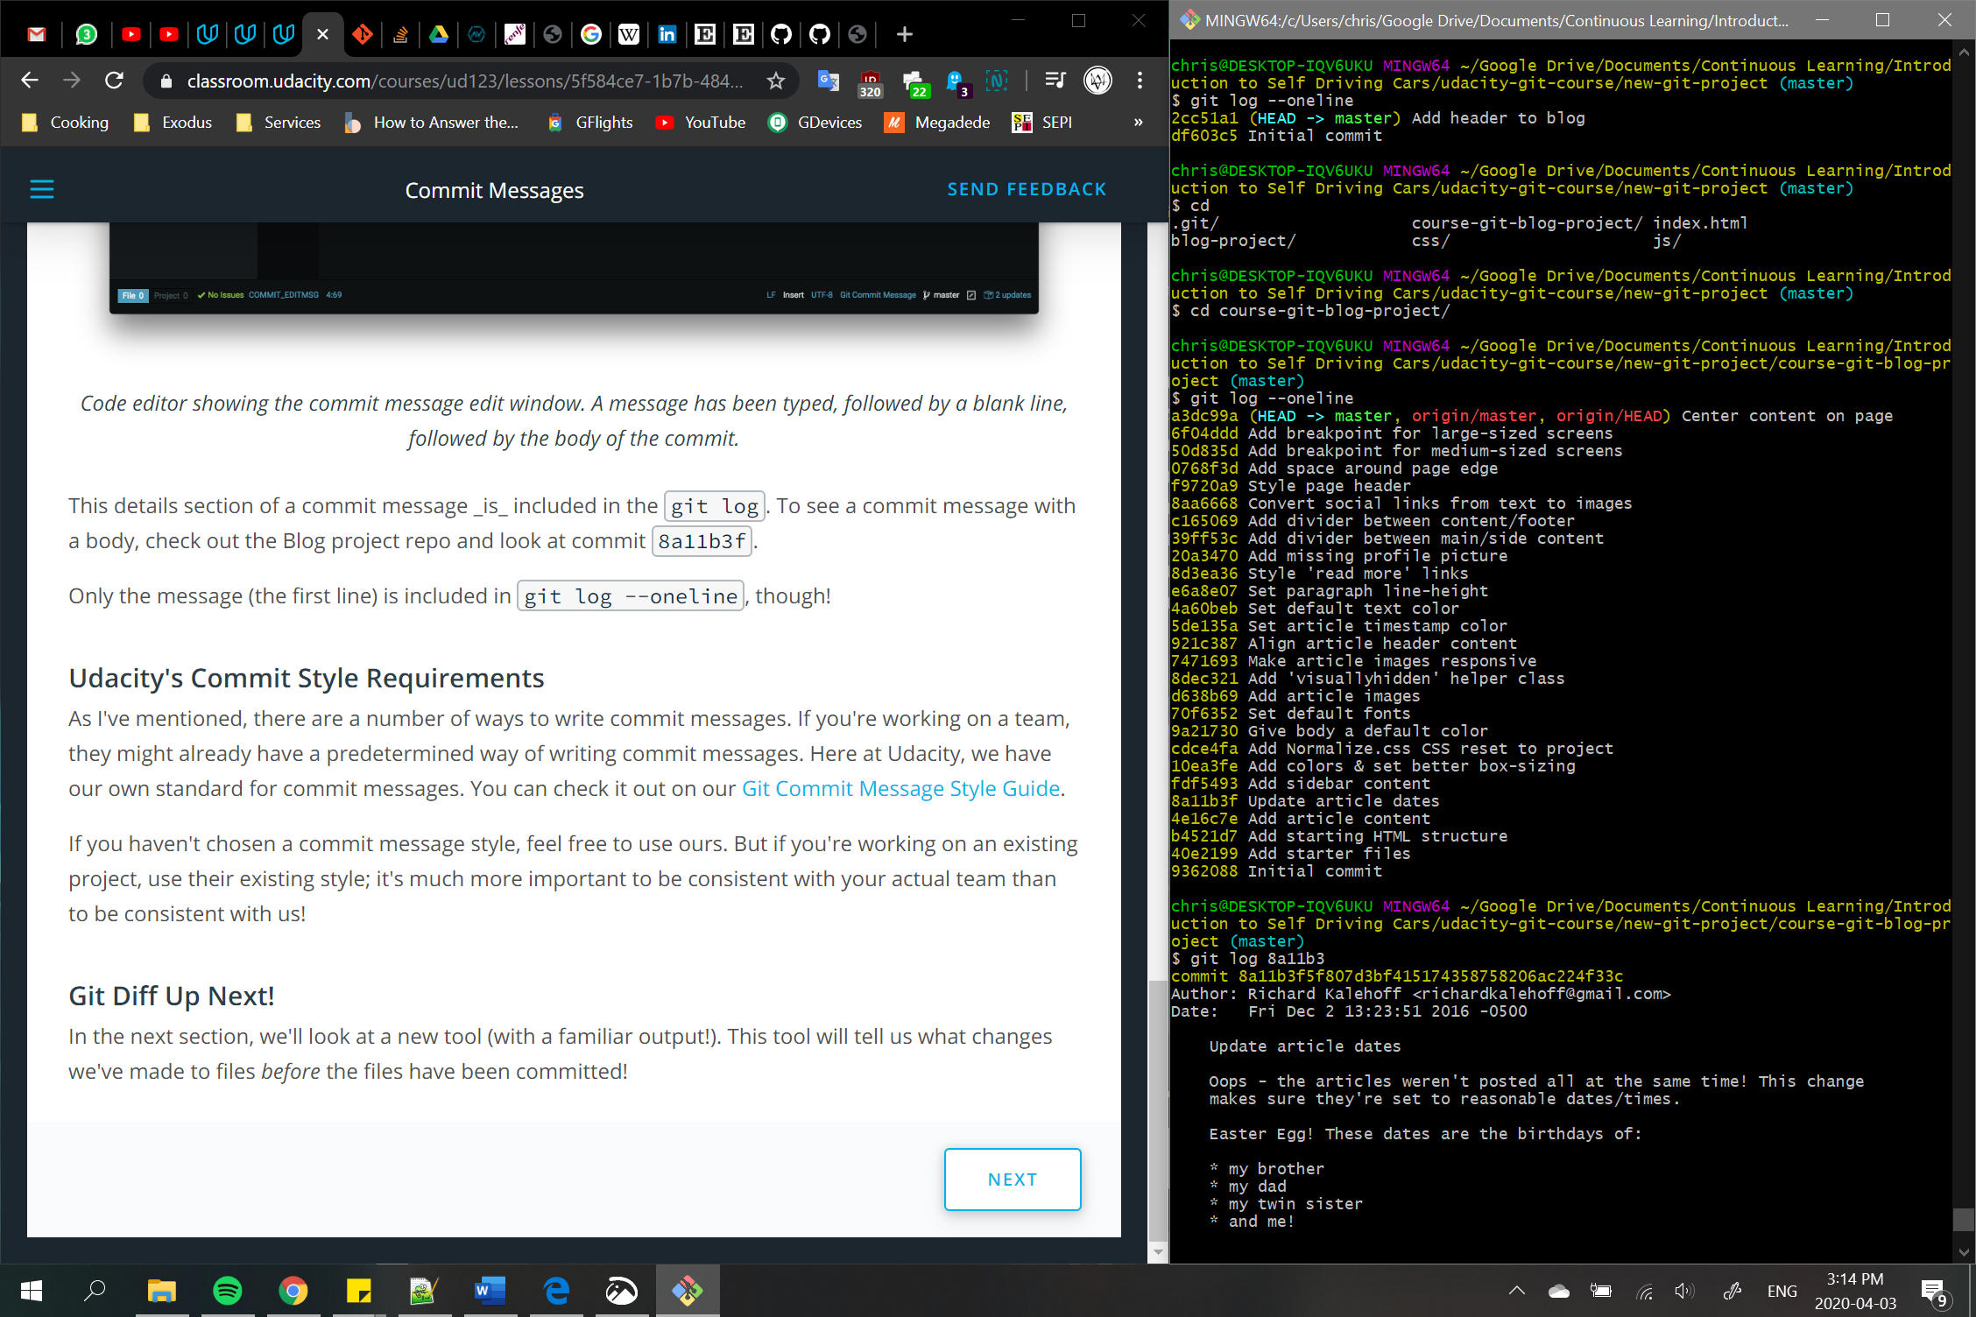

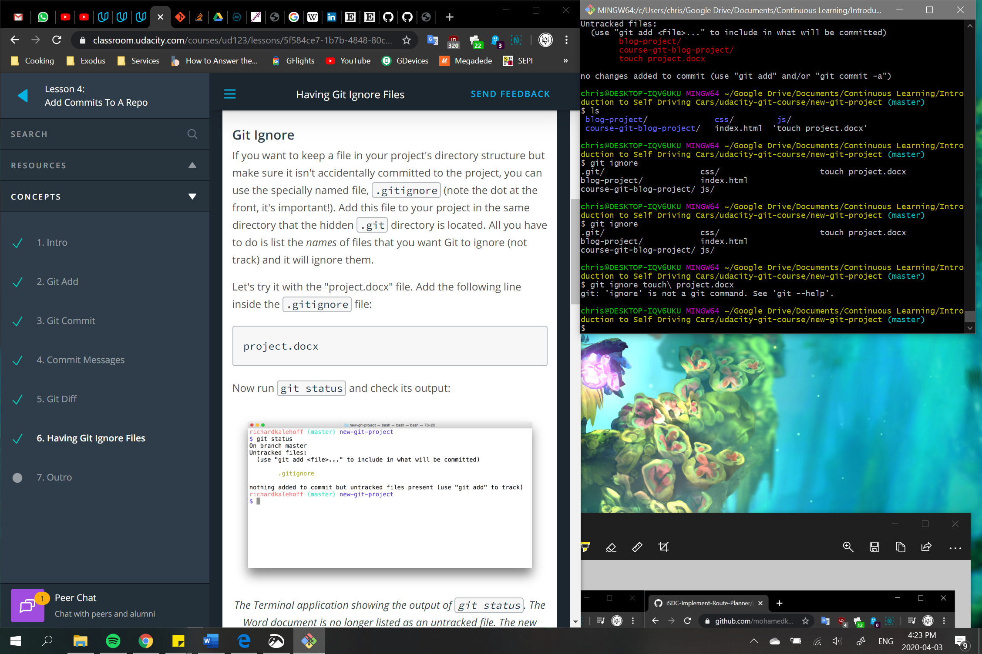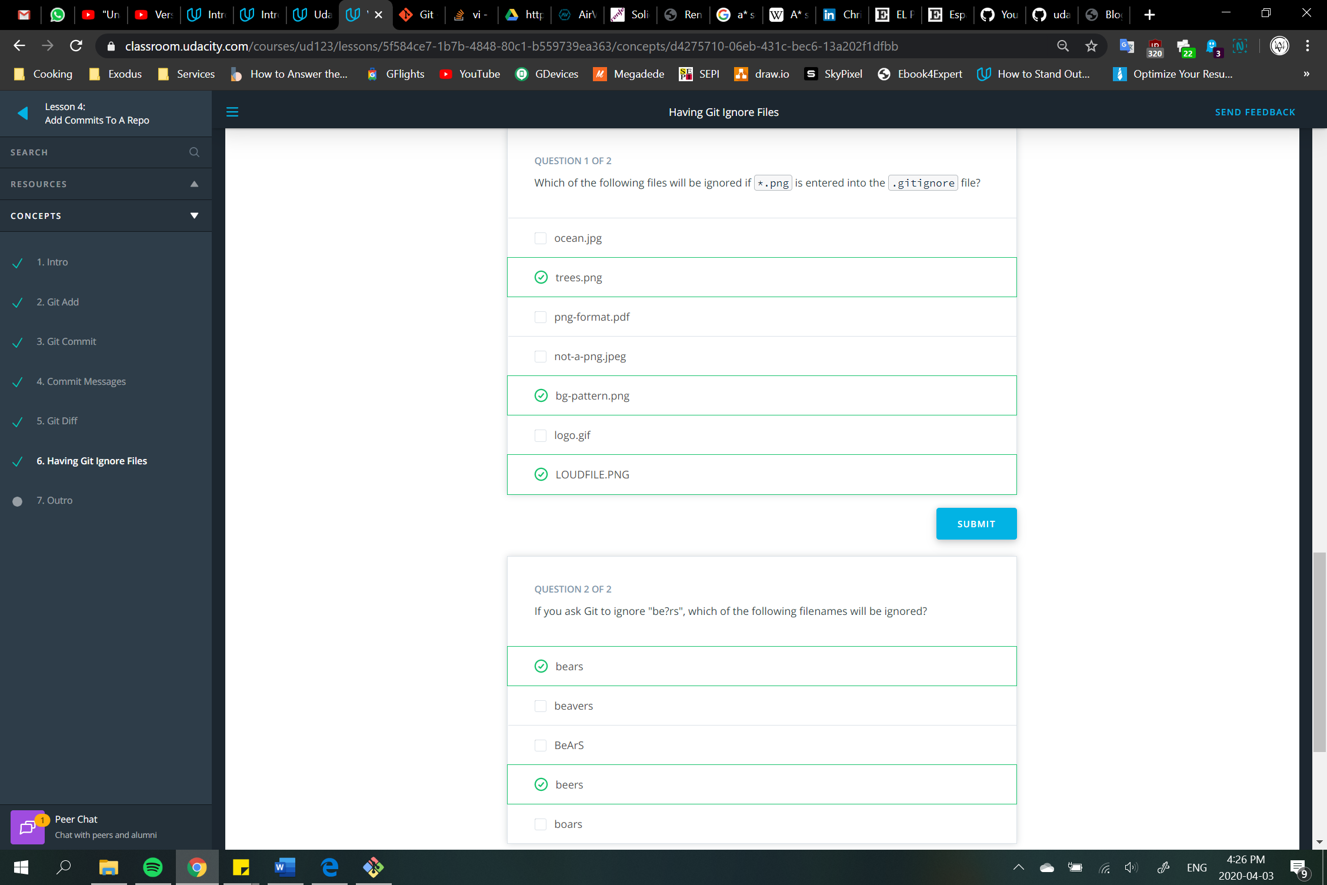

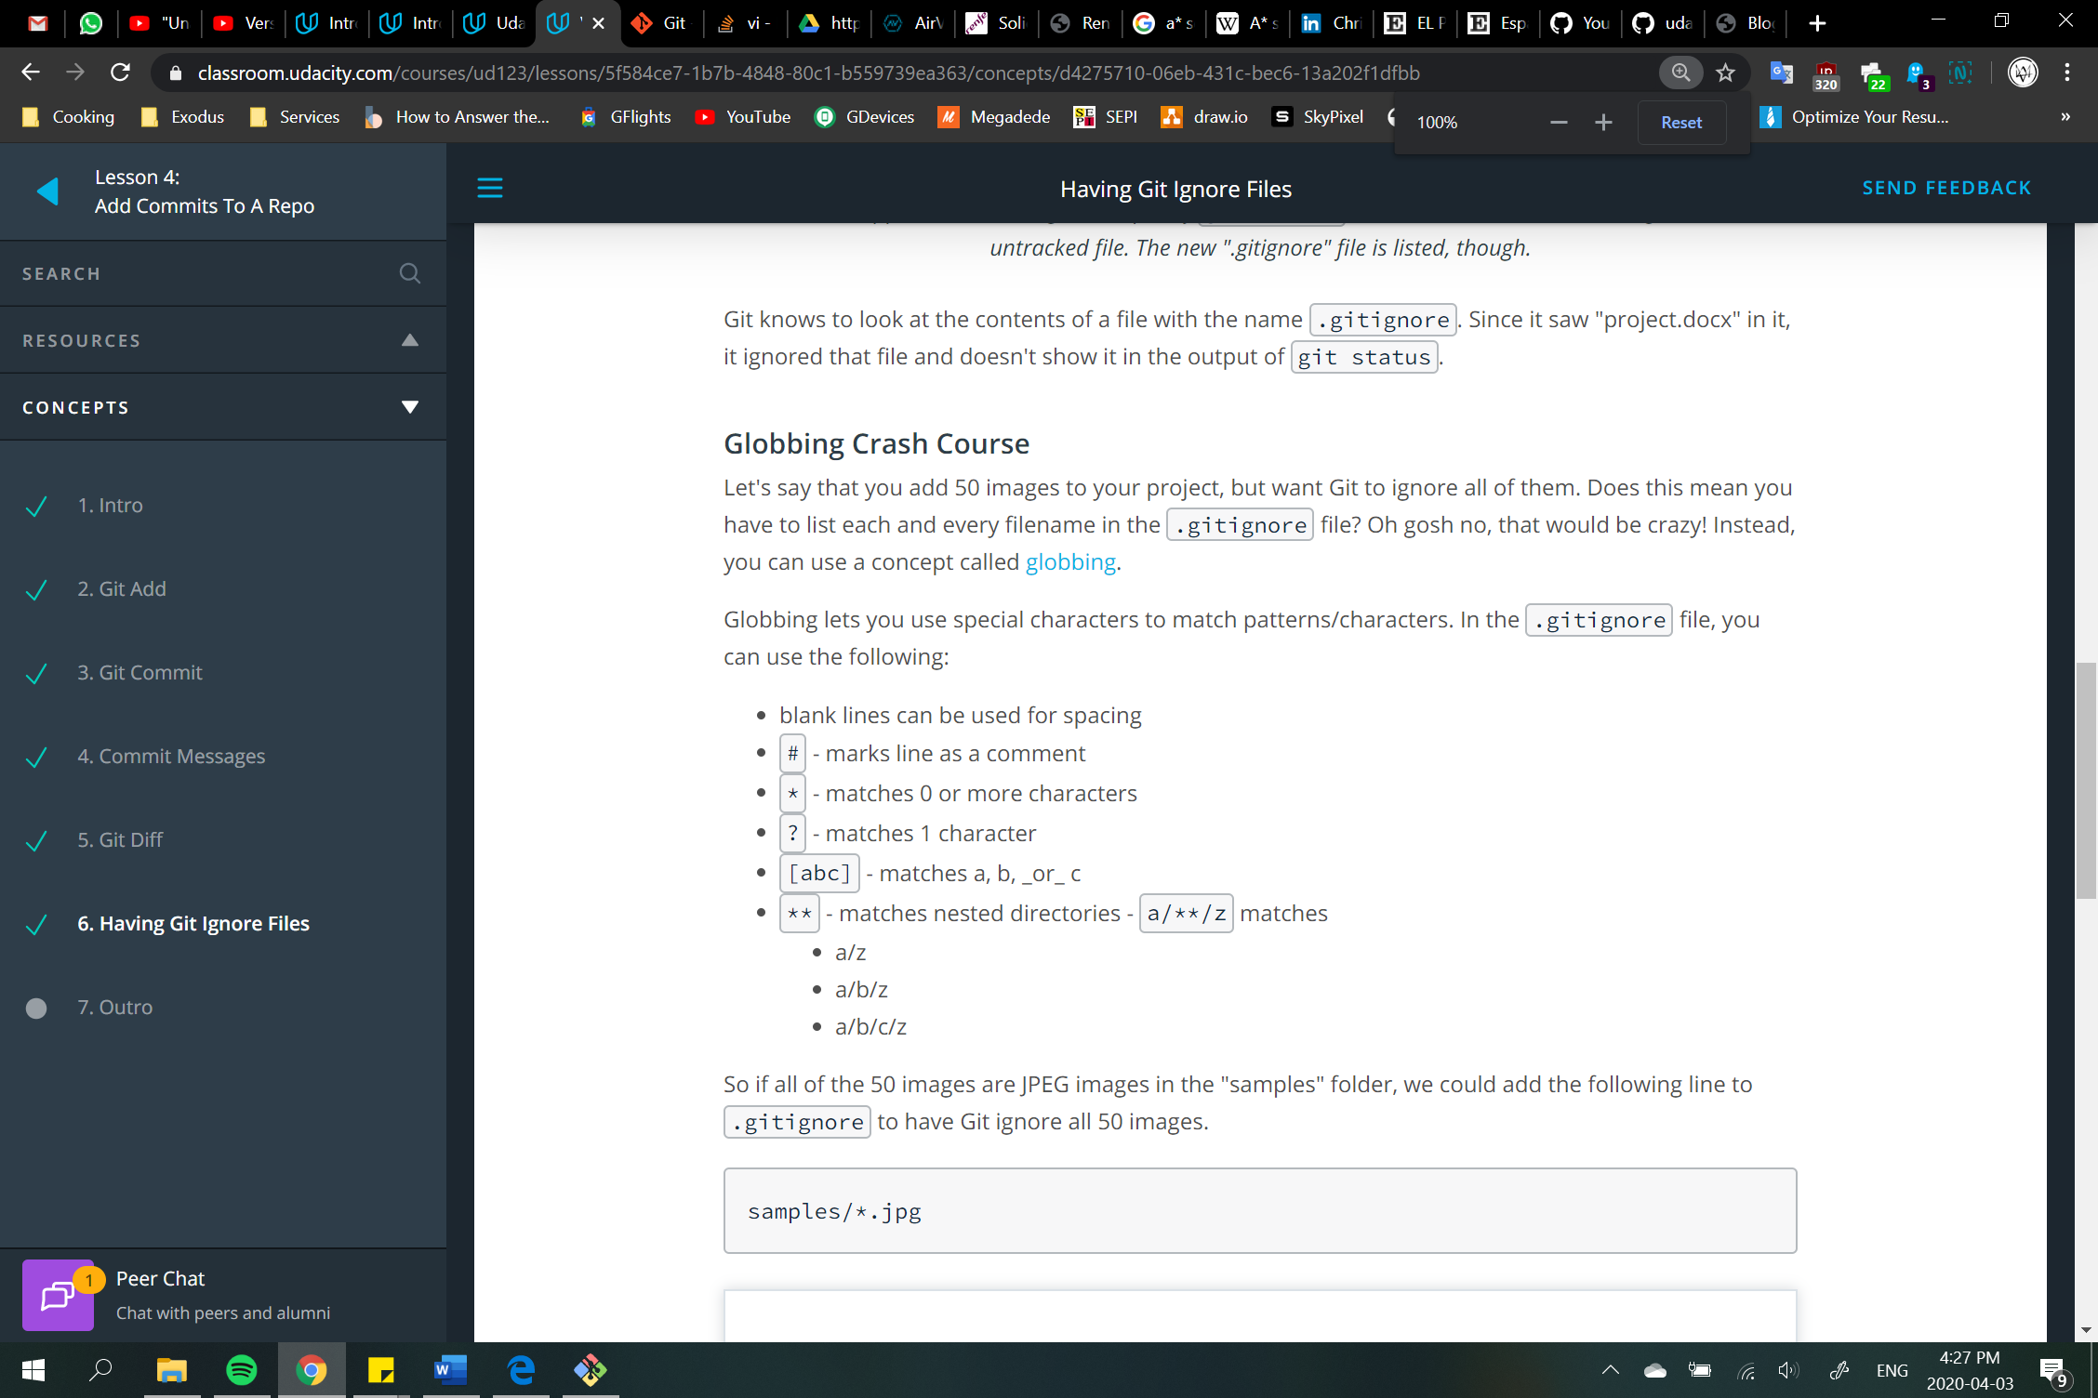

git tag 🡪 give tags to specific commits

-a “name of the tag” 🡪 to indicate what tag name is

SHA 🡪 indicate such tag in such commit

--delete or -d “name of the tag” 🡪 to remove such tag

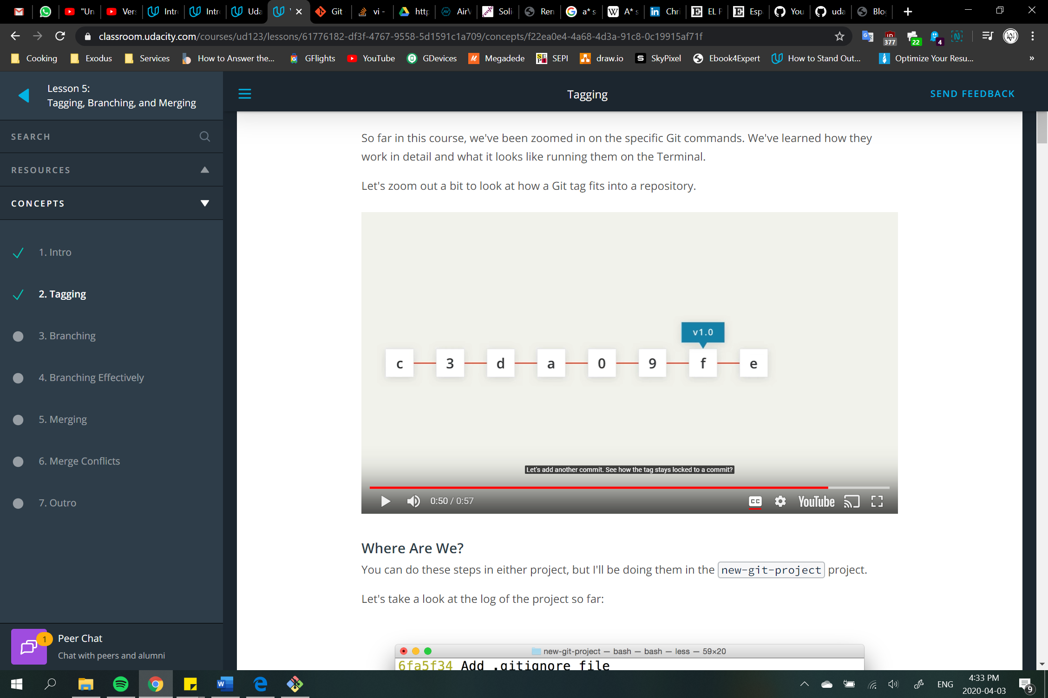 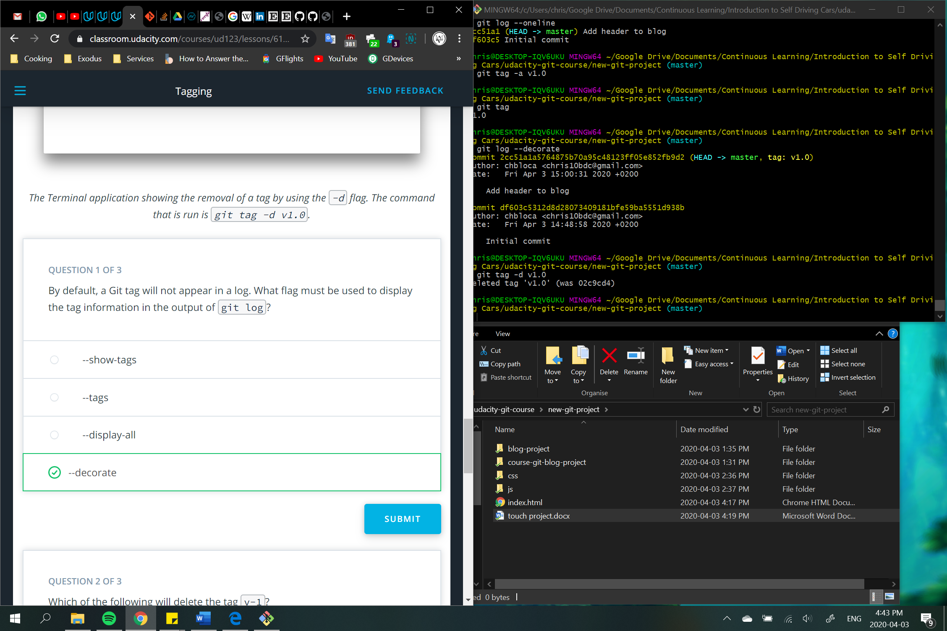

git branch 🡪 create different lines of development

“name of the branch” 🡪 create branch

-d “name of the branch” 🡪 delete such branch  
 Git won't let you delete a branch if it has commits on it that aren't on any other branch  
 Git wouldn't let you delete the branch because you can't delete a branch that you're currently on  
 -D “name of the branch” 🡪 force removal

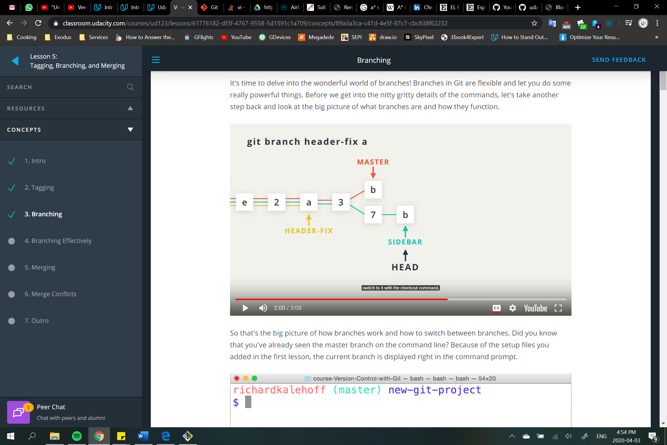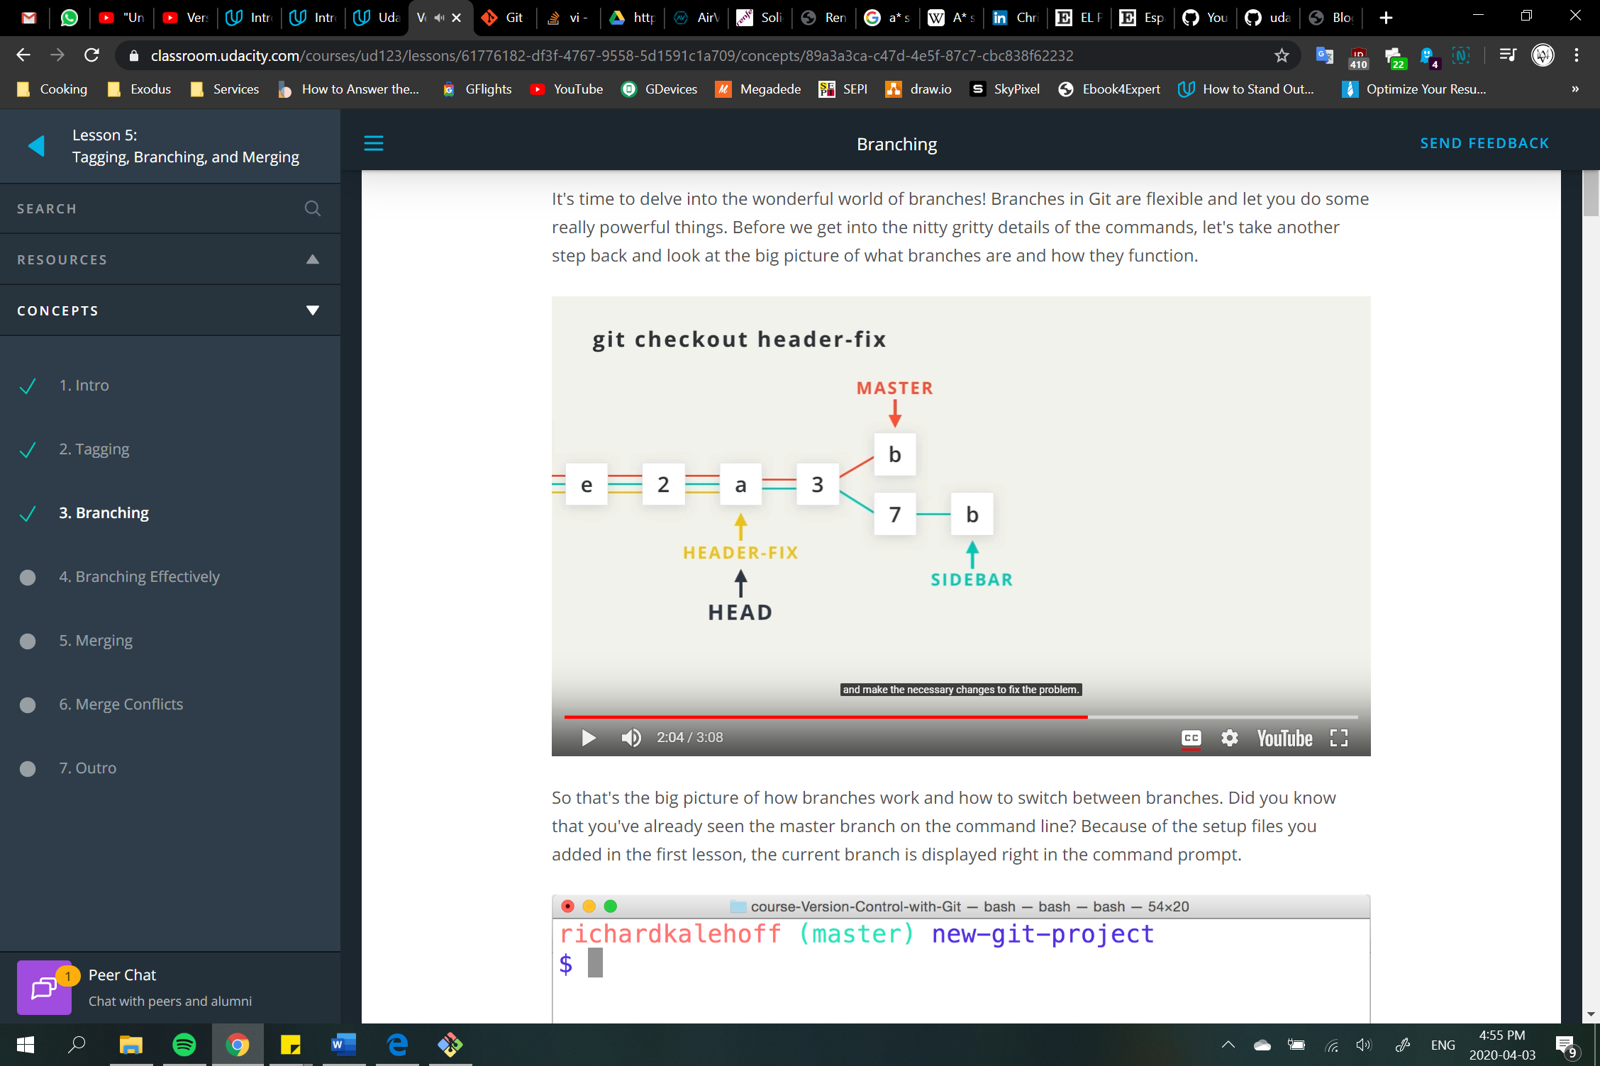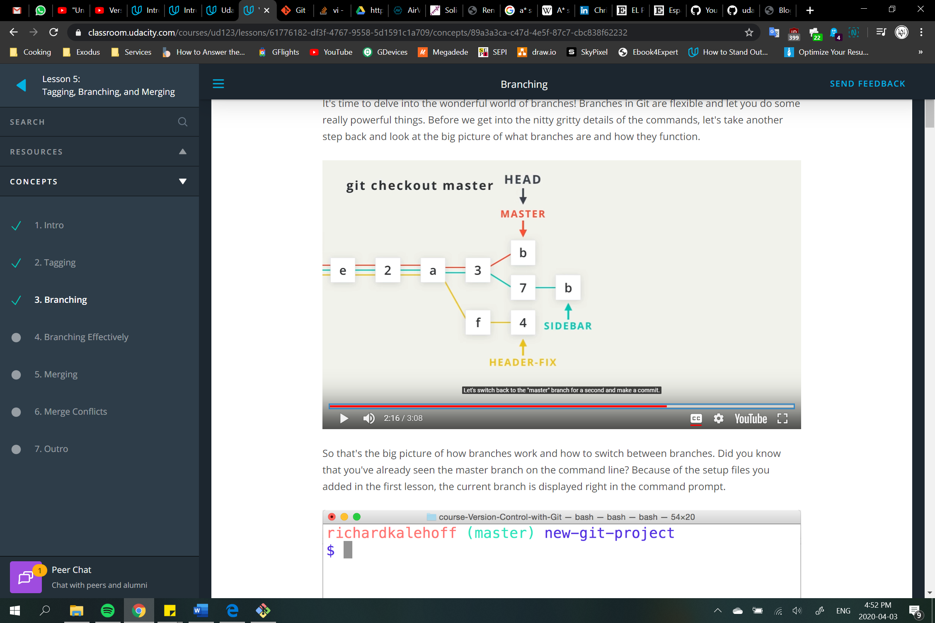

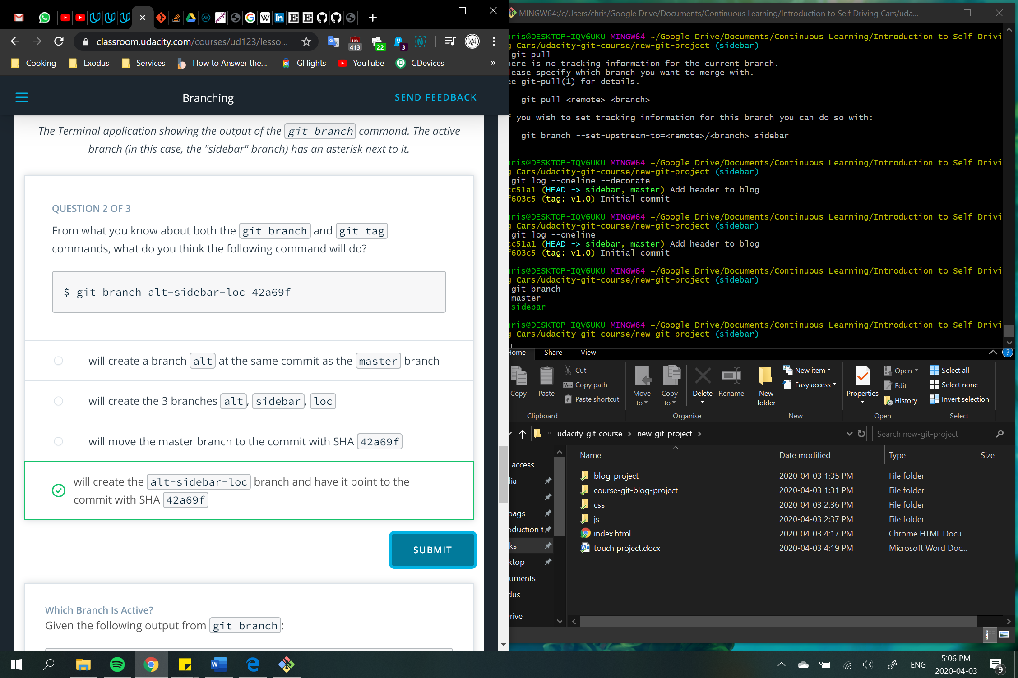

git checkout 🡪 switch between different branches and tags

“name of branch” 🡪 change header to that branch

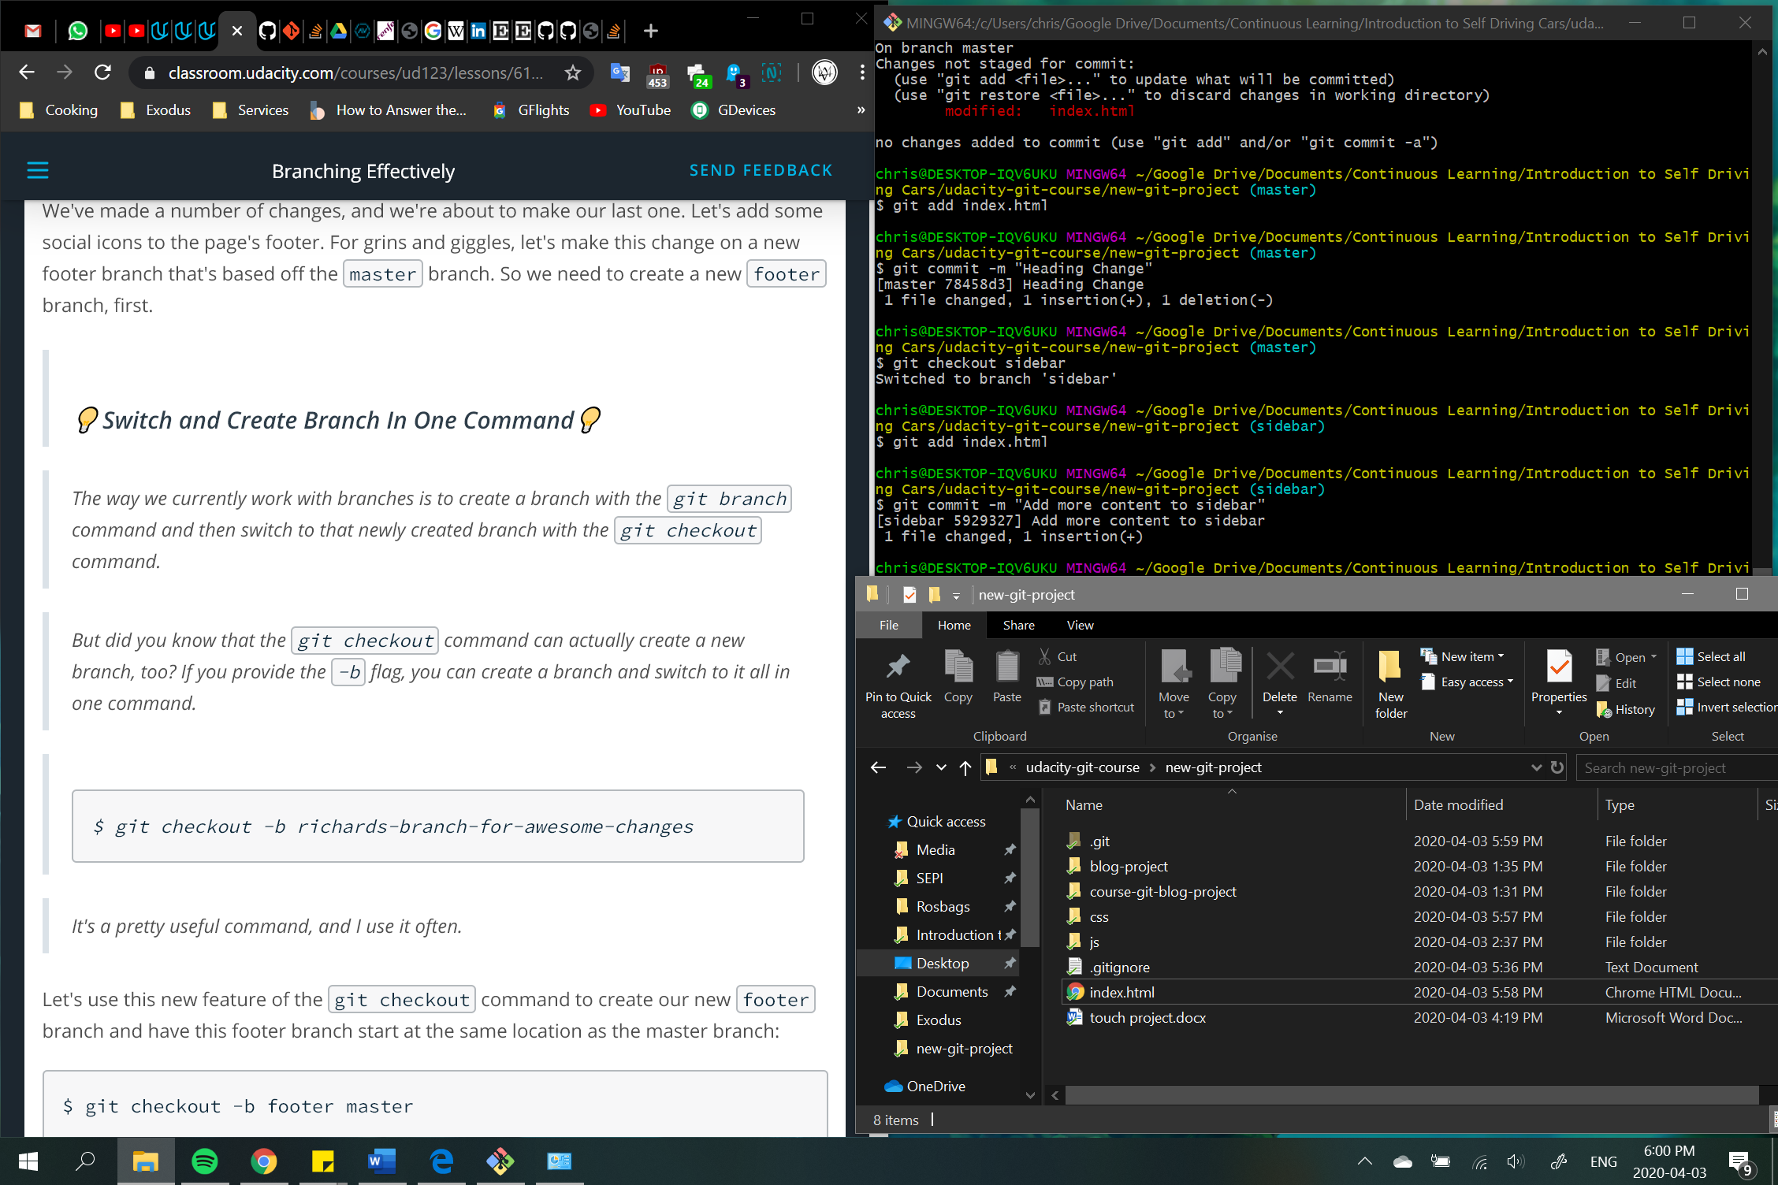 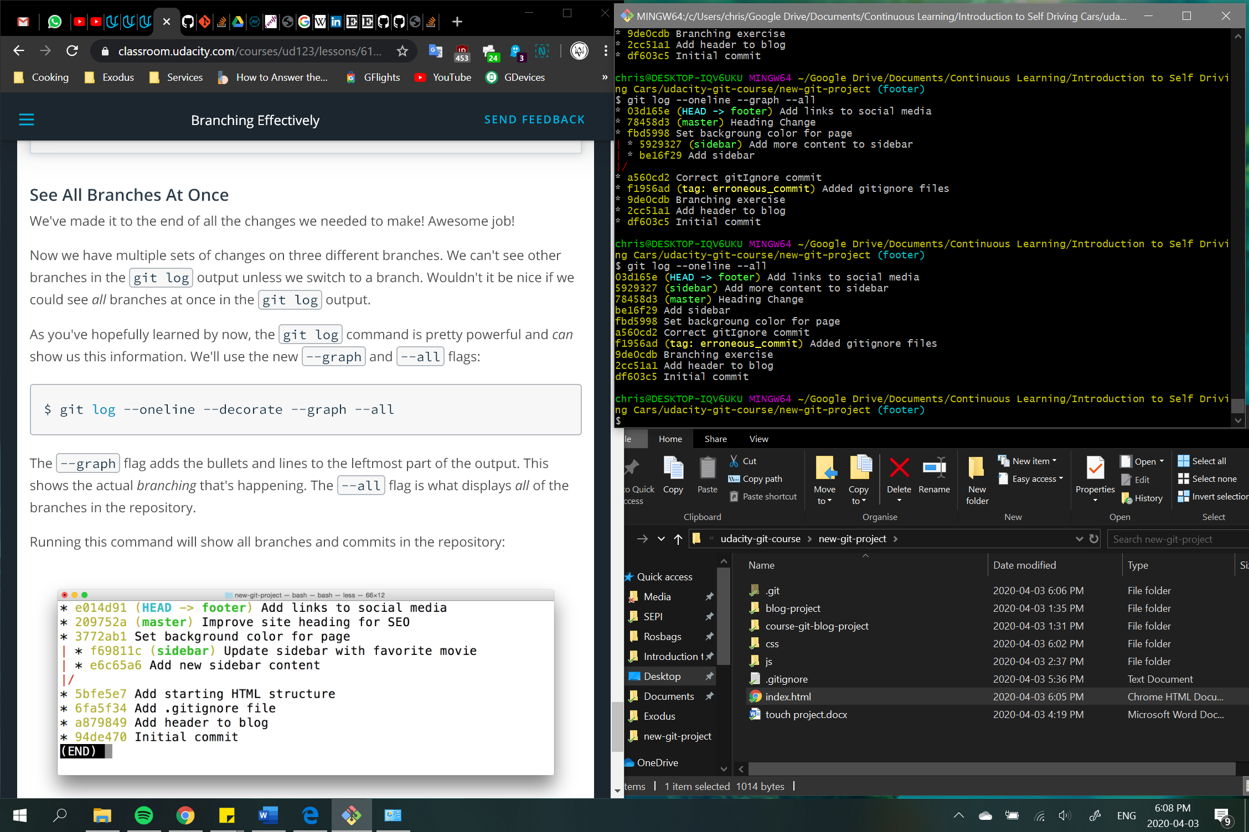

git merge 🡪 combine changes on different branches  
When we merge, we're merging some other branch into the current (checked-out) branch

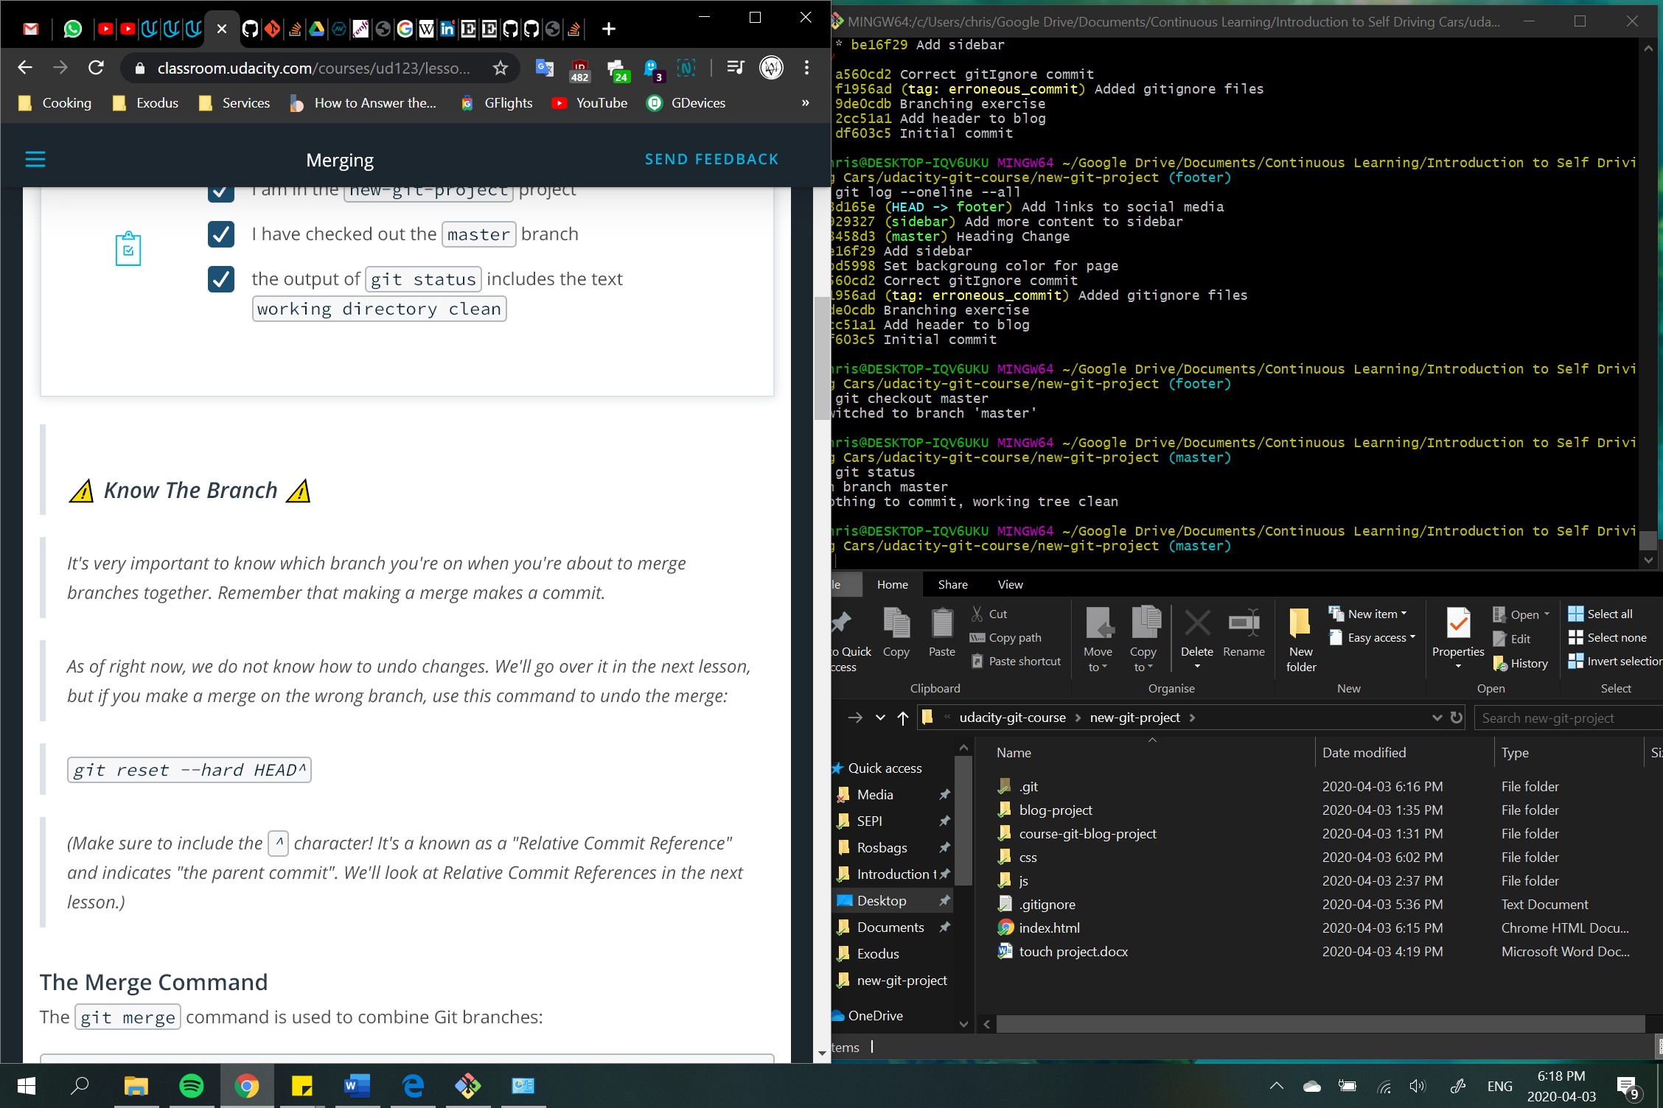

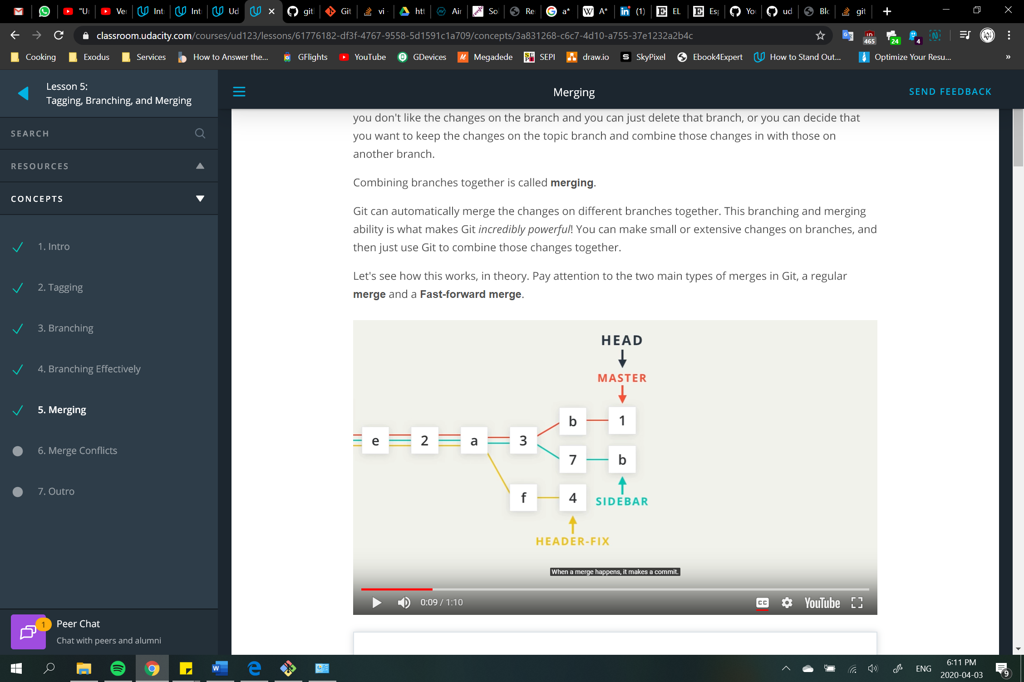 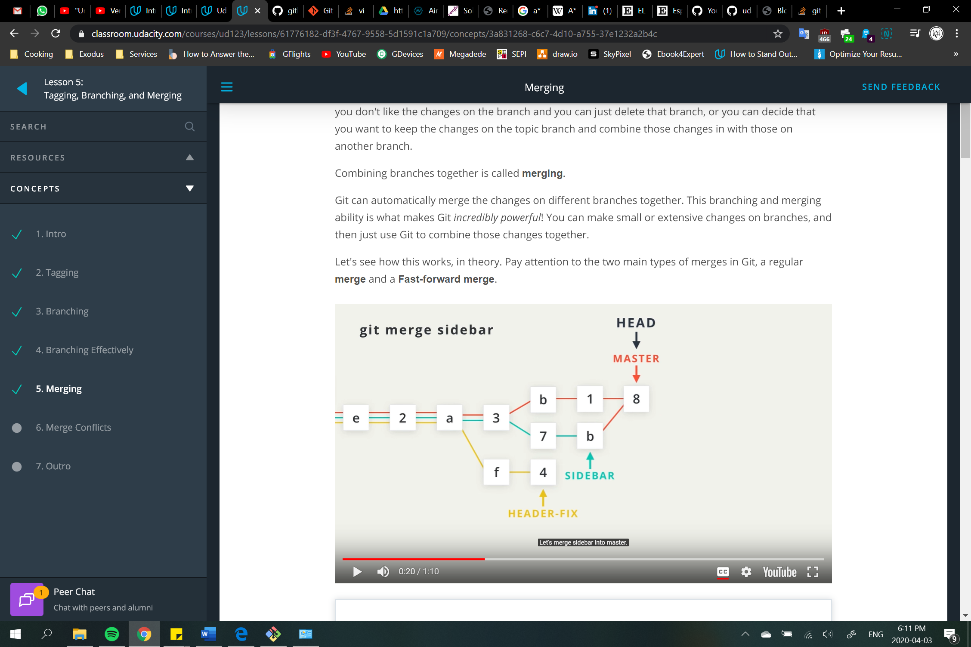 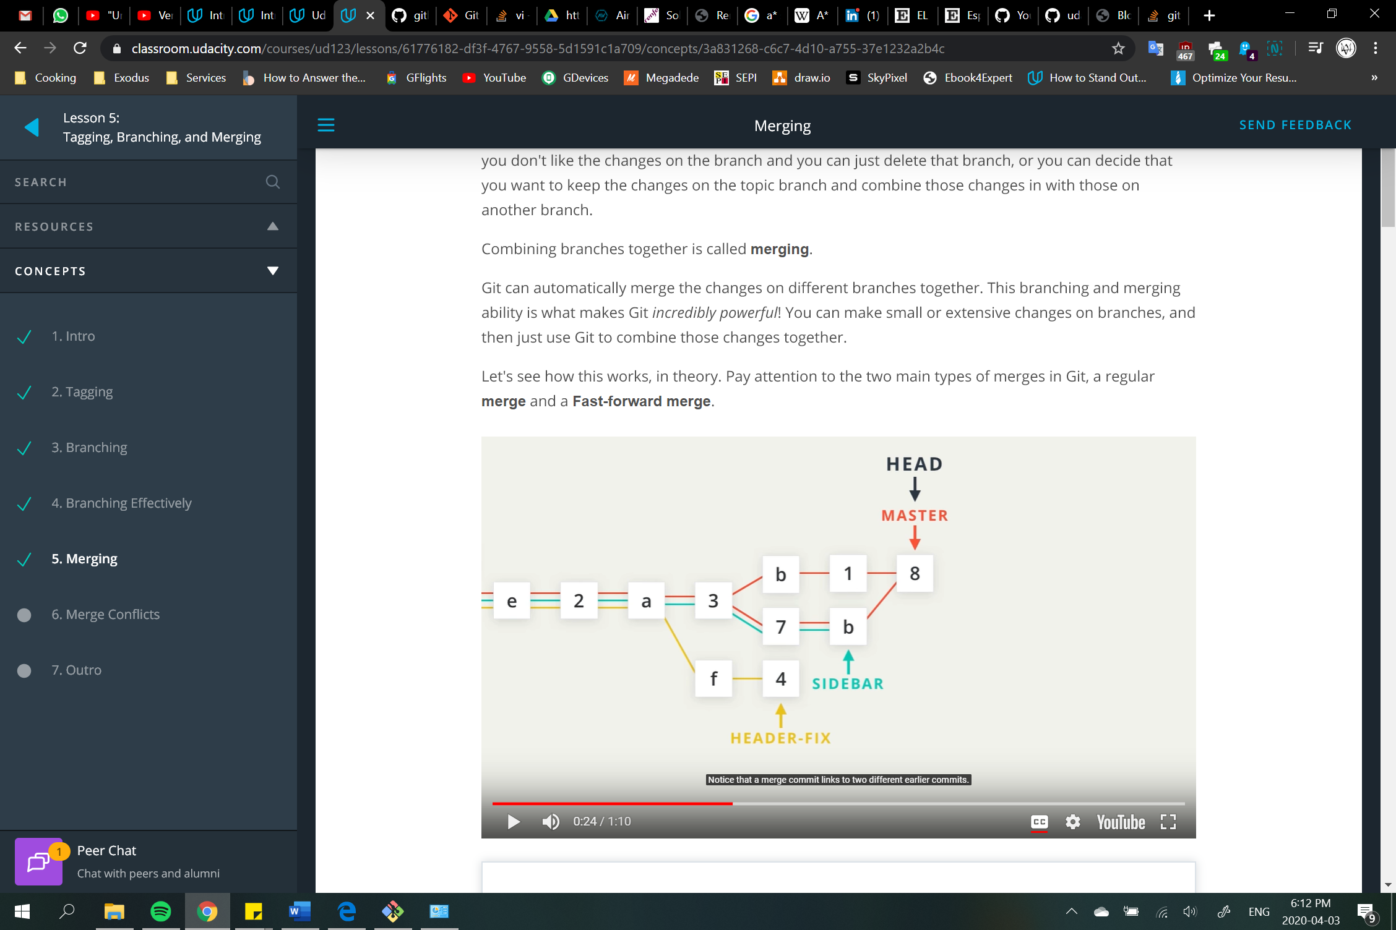

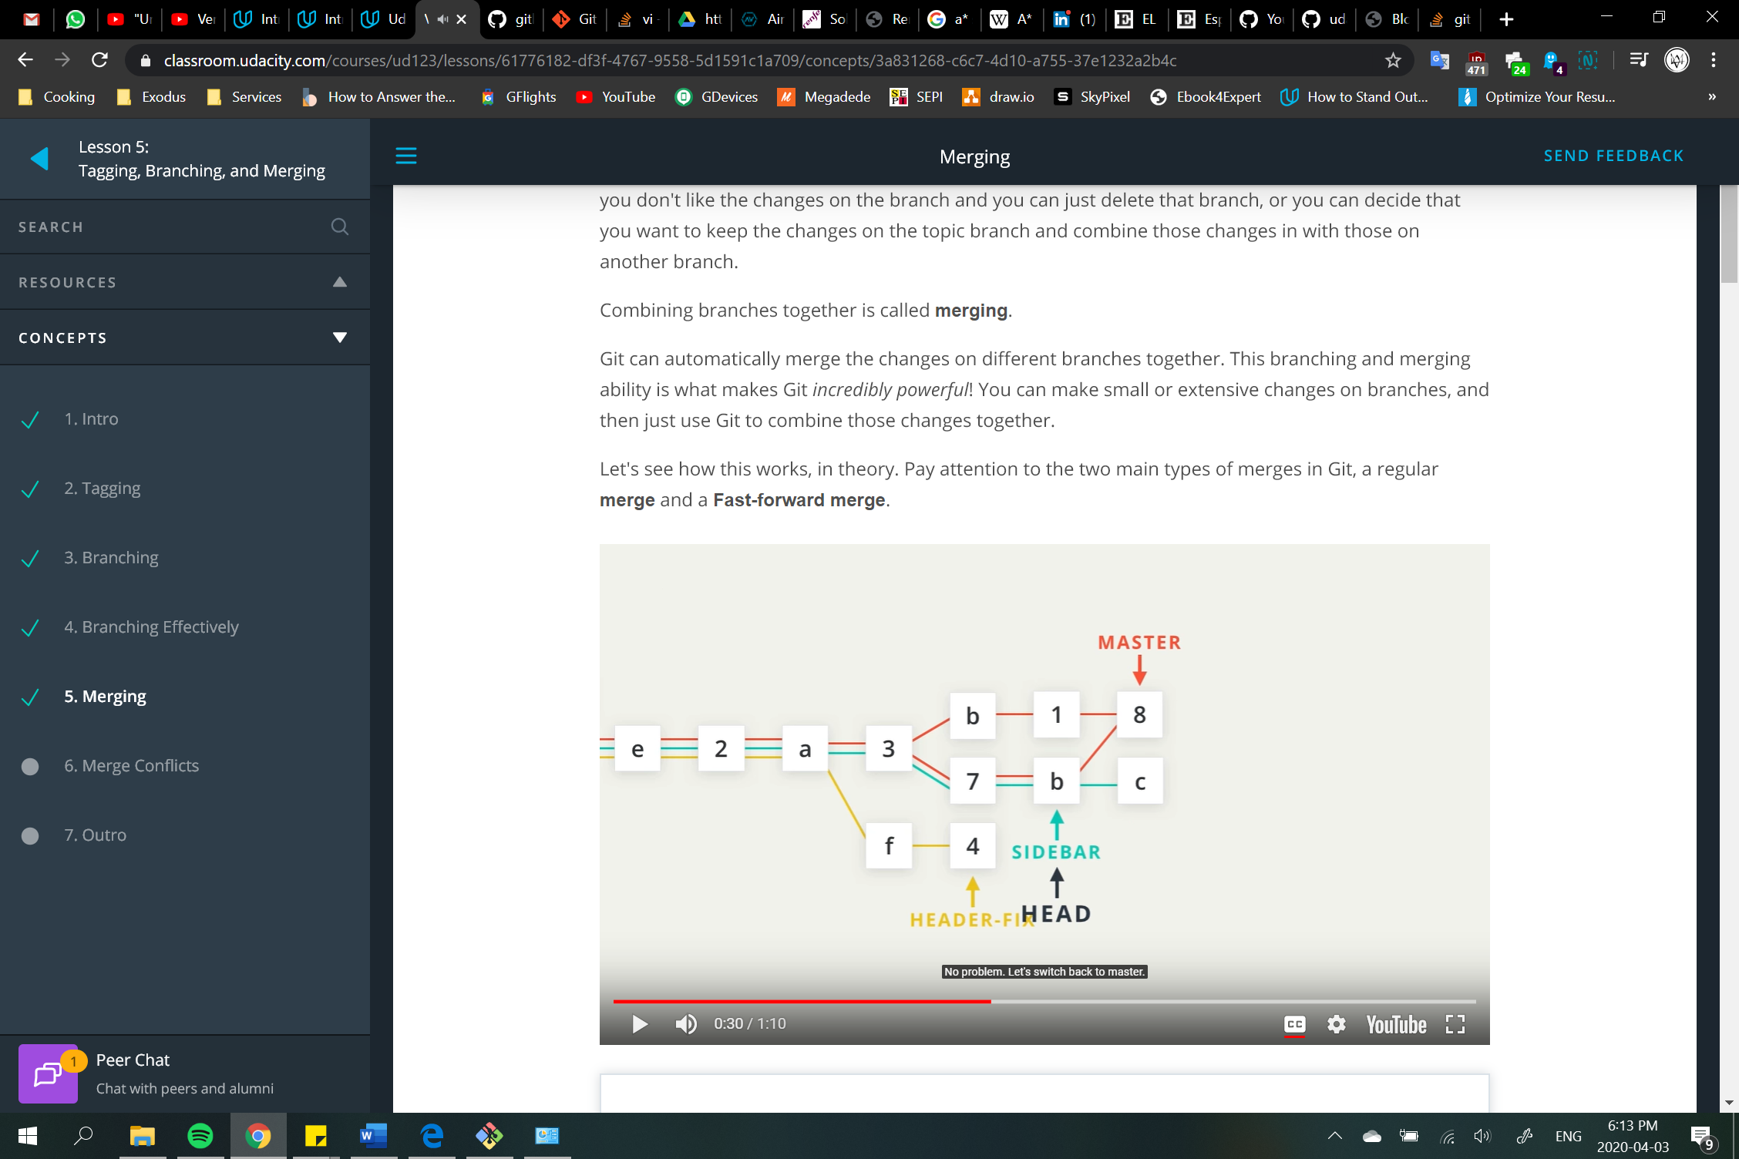 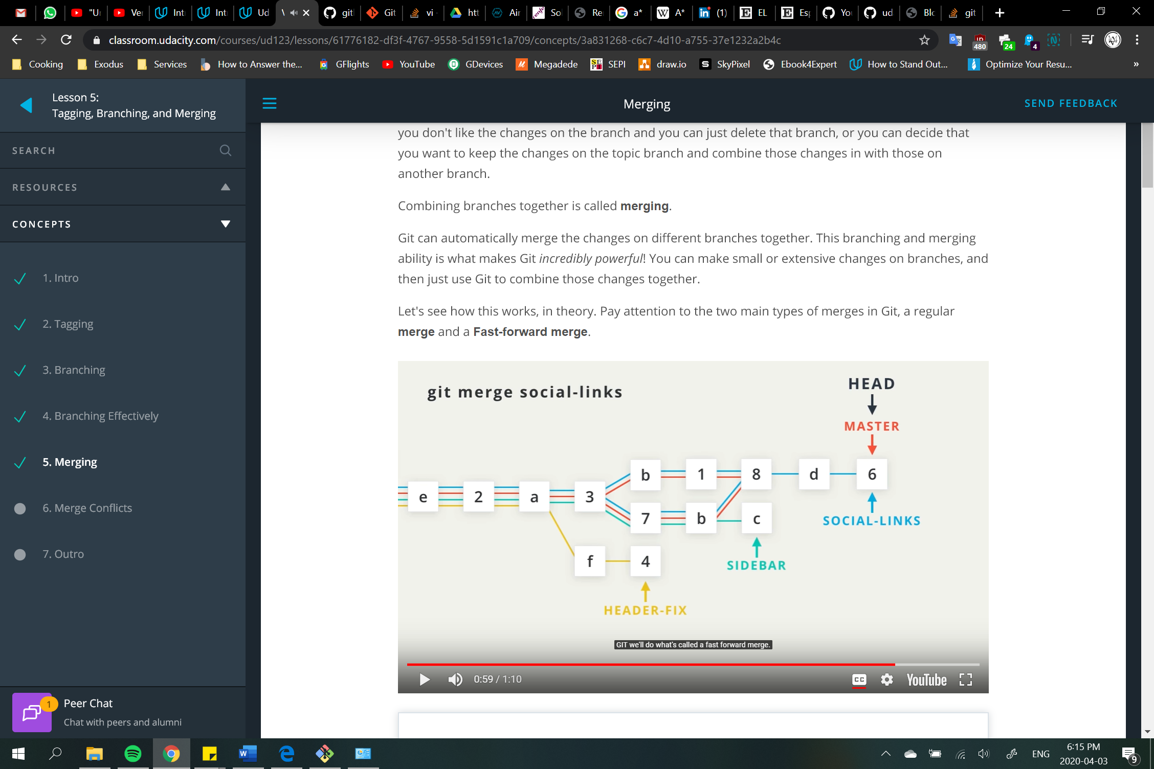

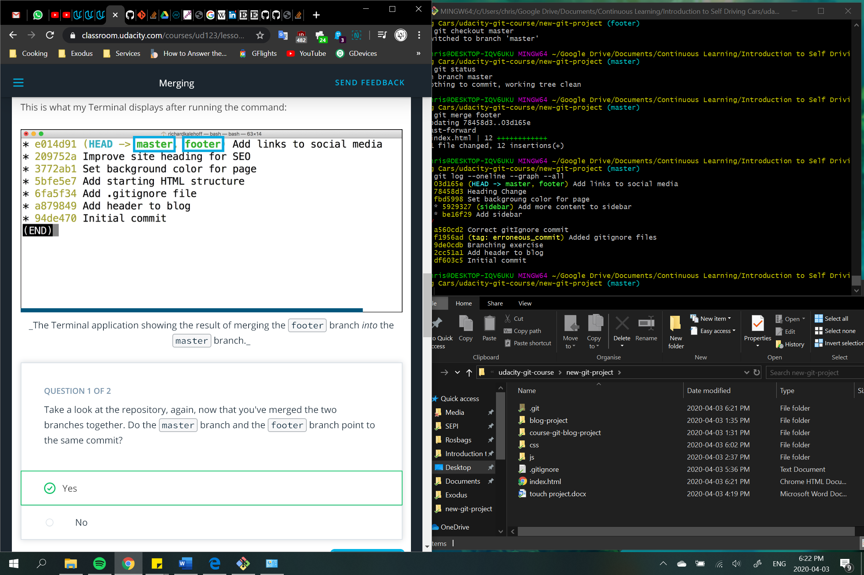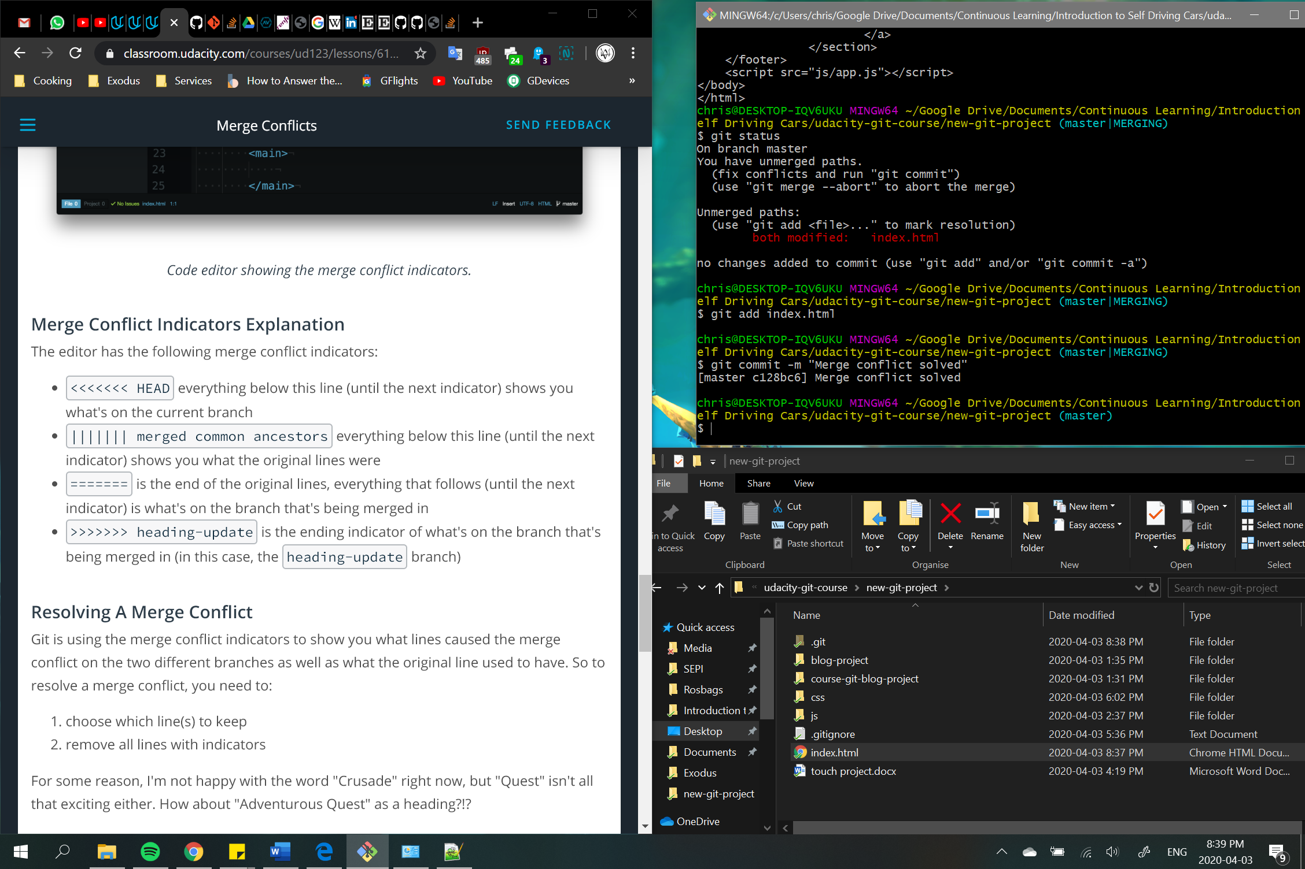

git commit --amend 🡪 alter the most-recent commit

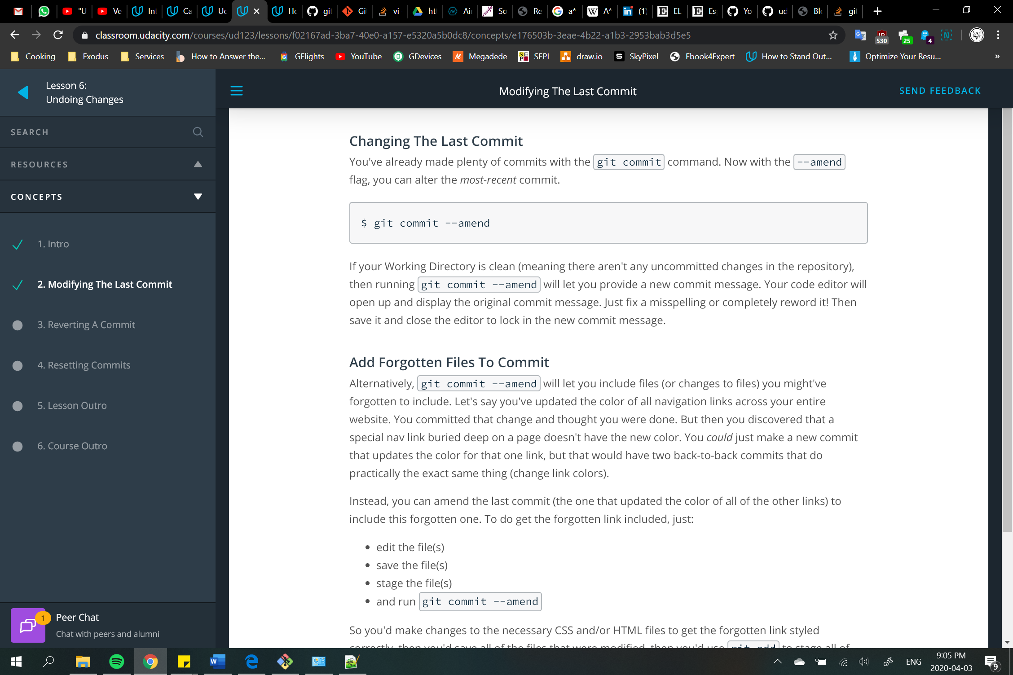

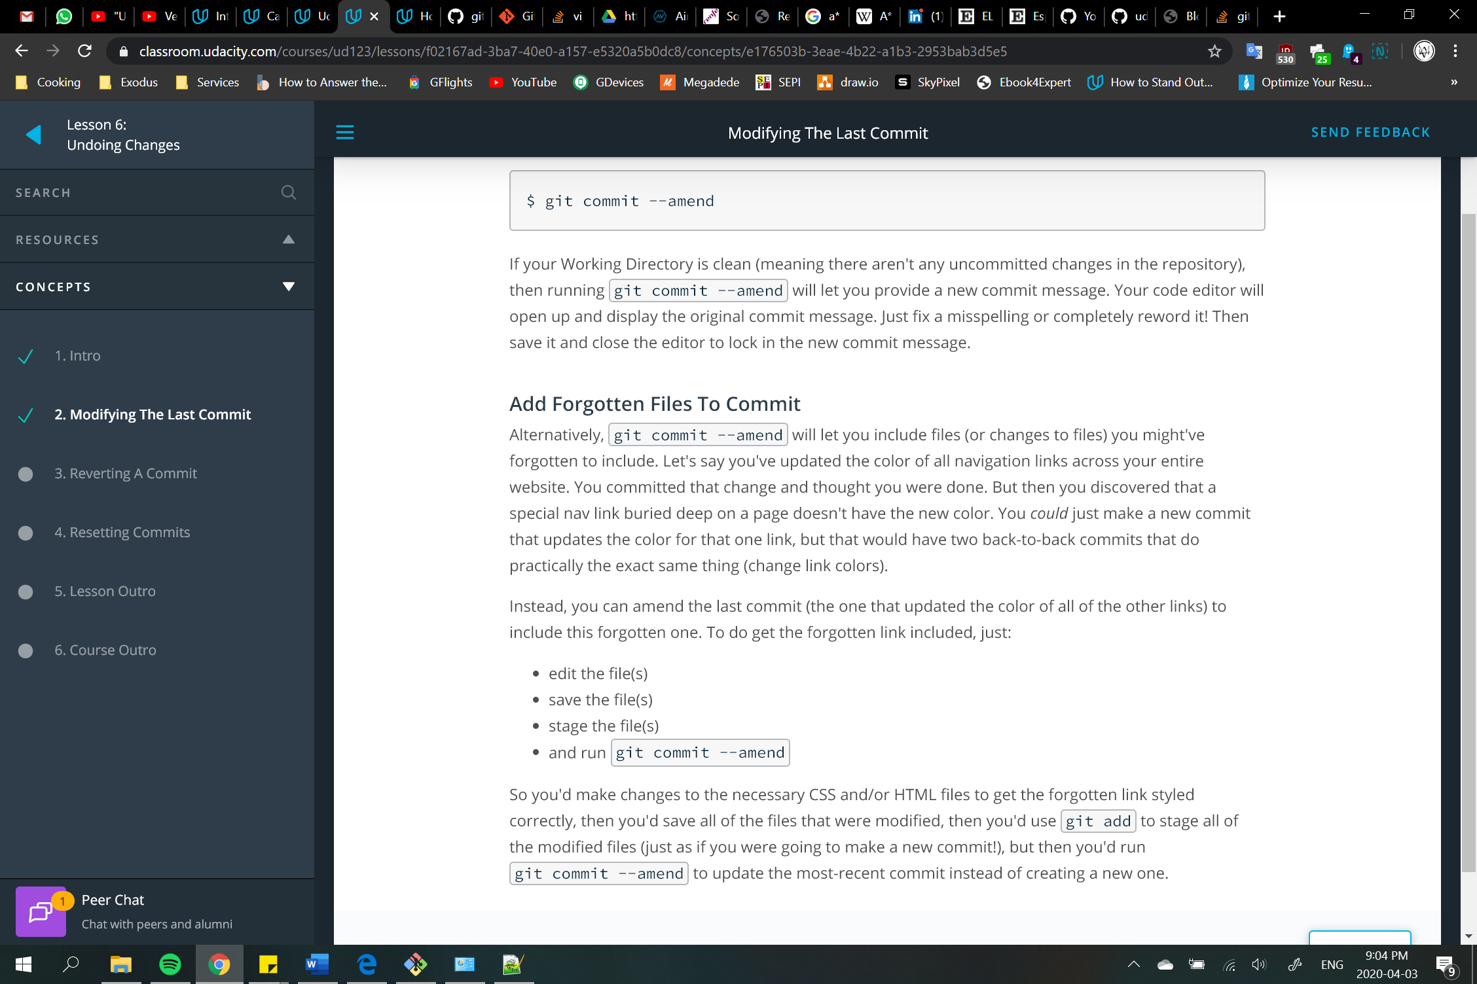

git revert 🡪 reverses given commit

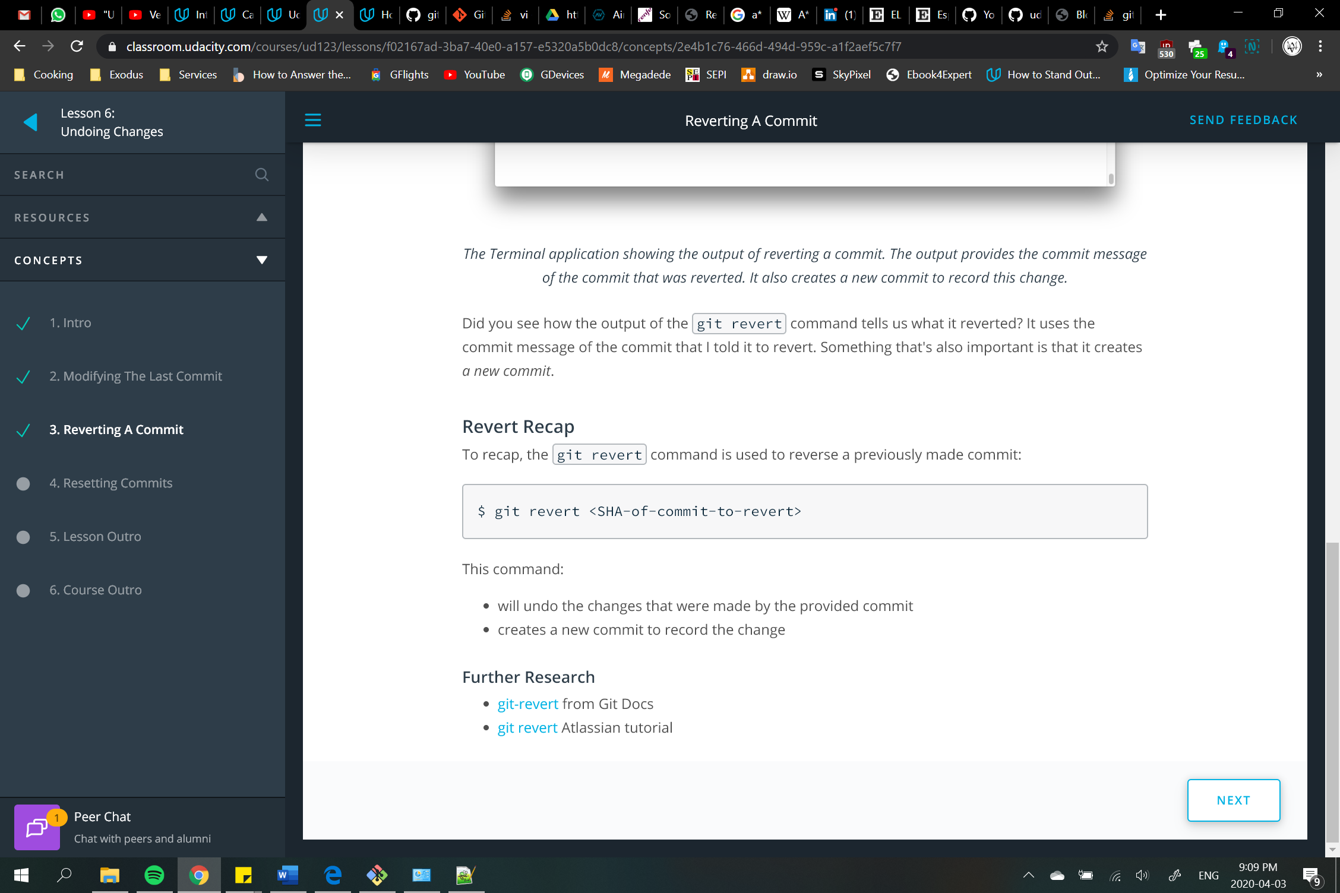

git reset 🡪 delete commits (only possible to do it sequentially) [POTENTIALLY DANGEROUS!]

--mixed  
 --soft  
 --hard

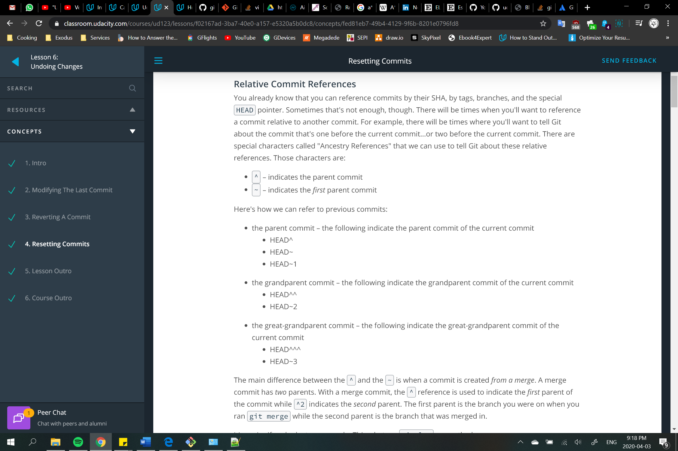 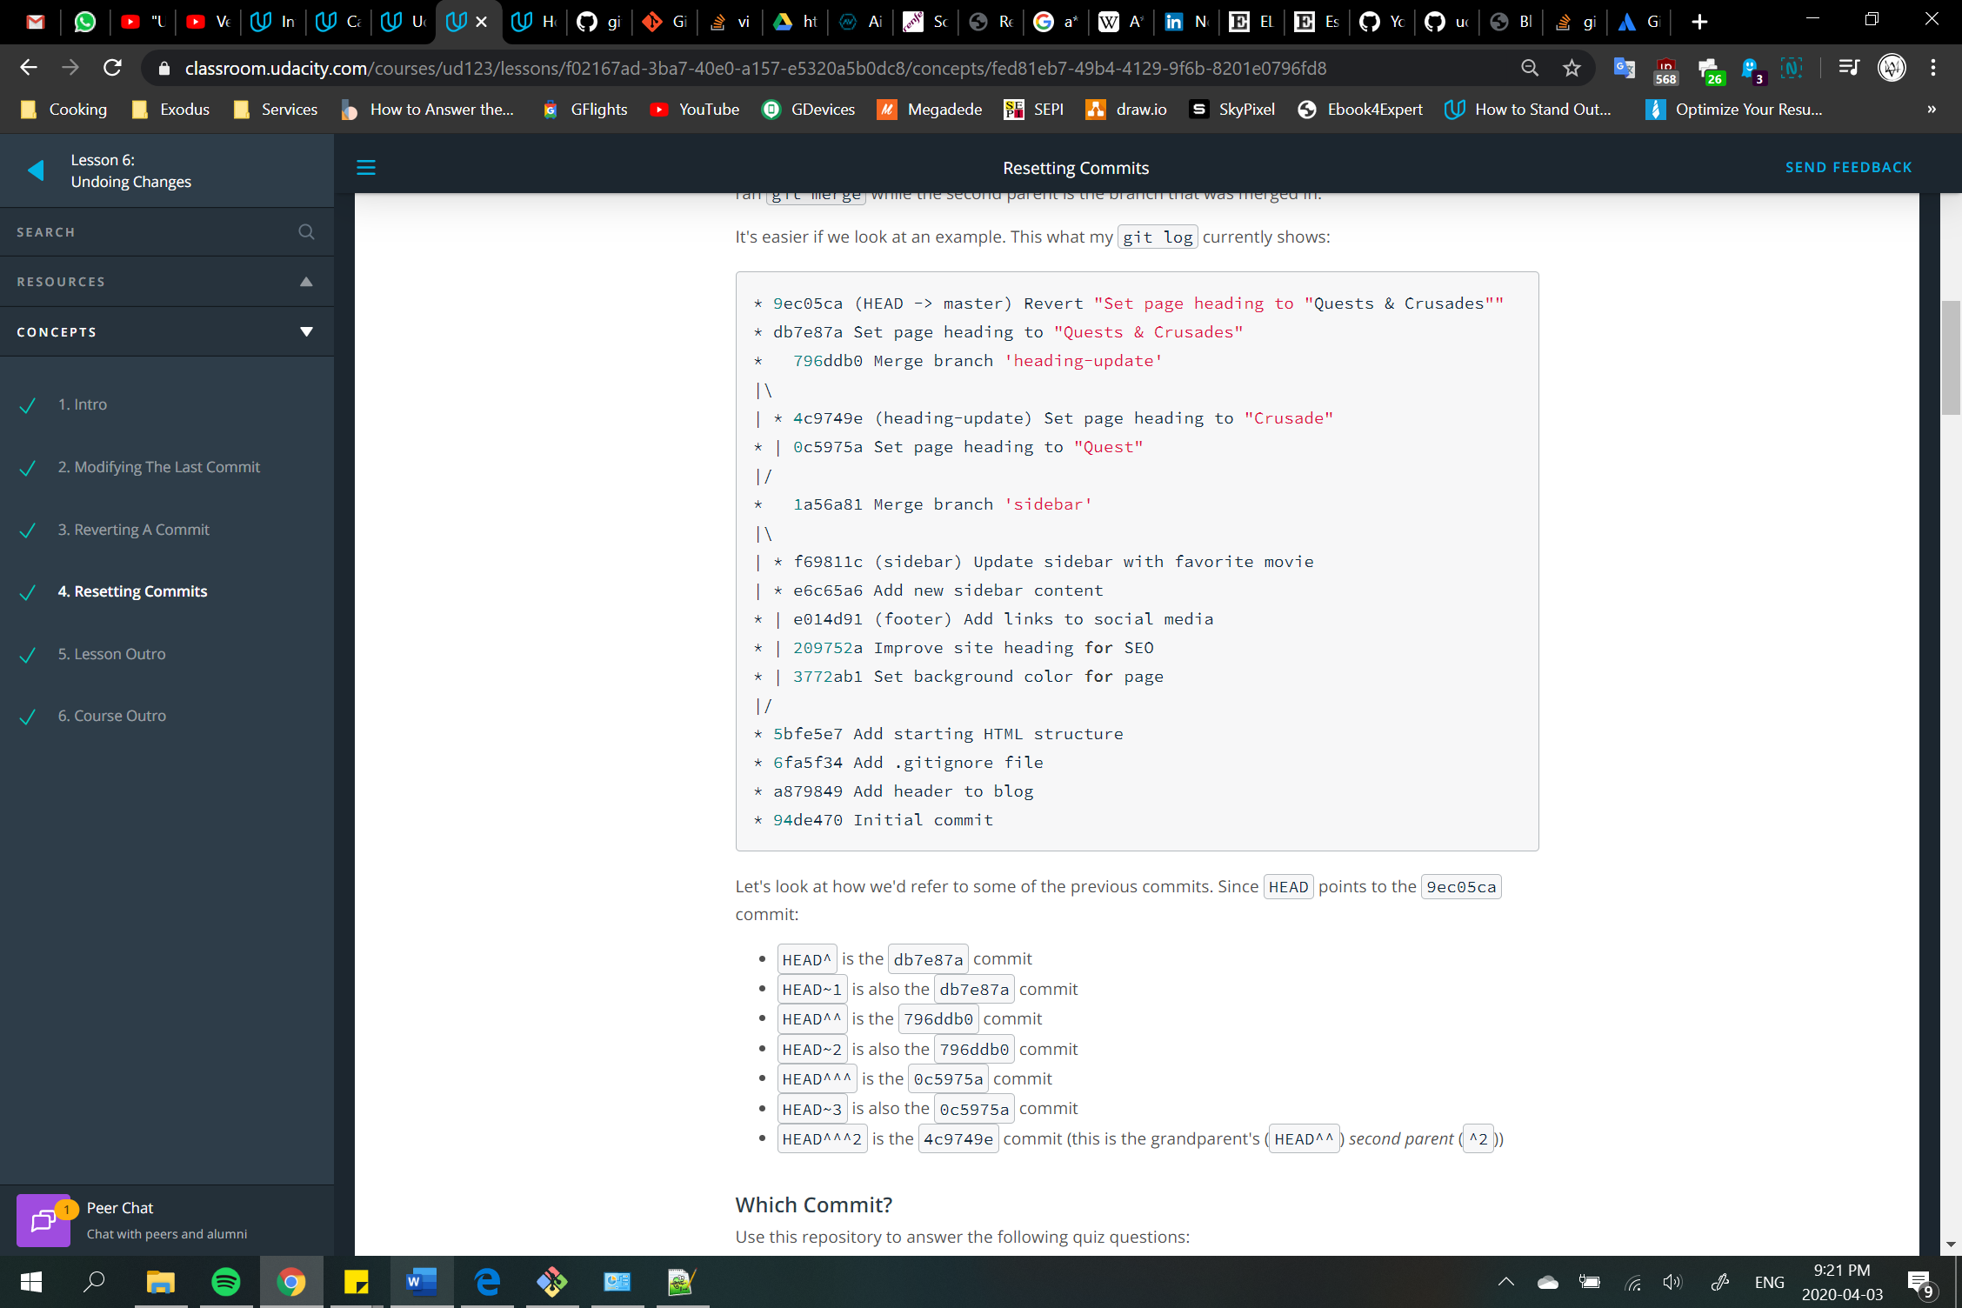

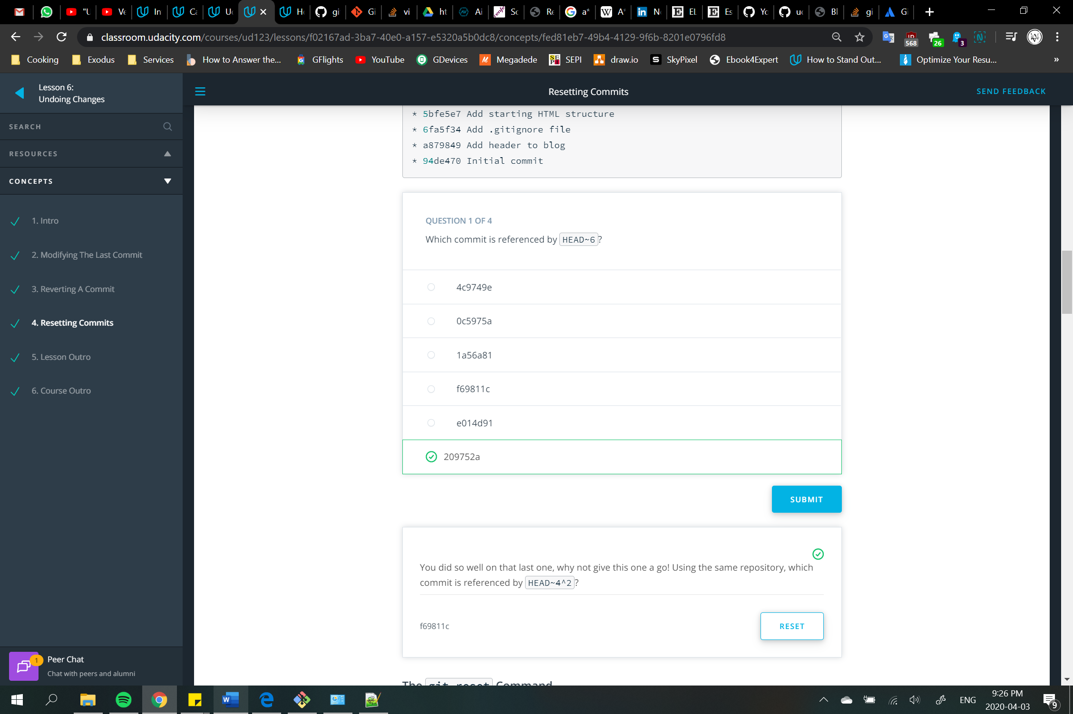

By default flag is set to mixed:

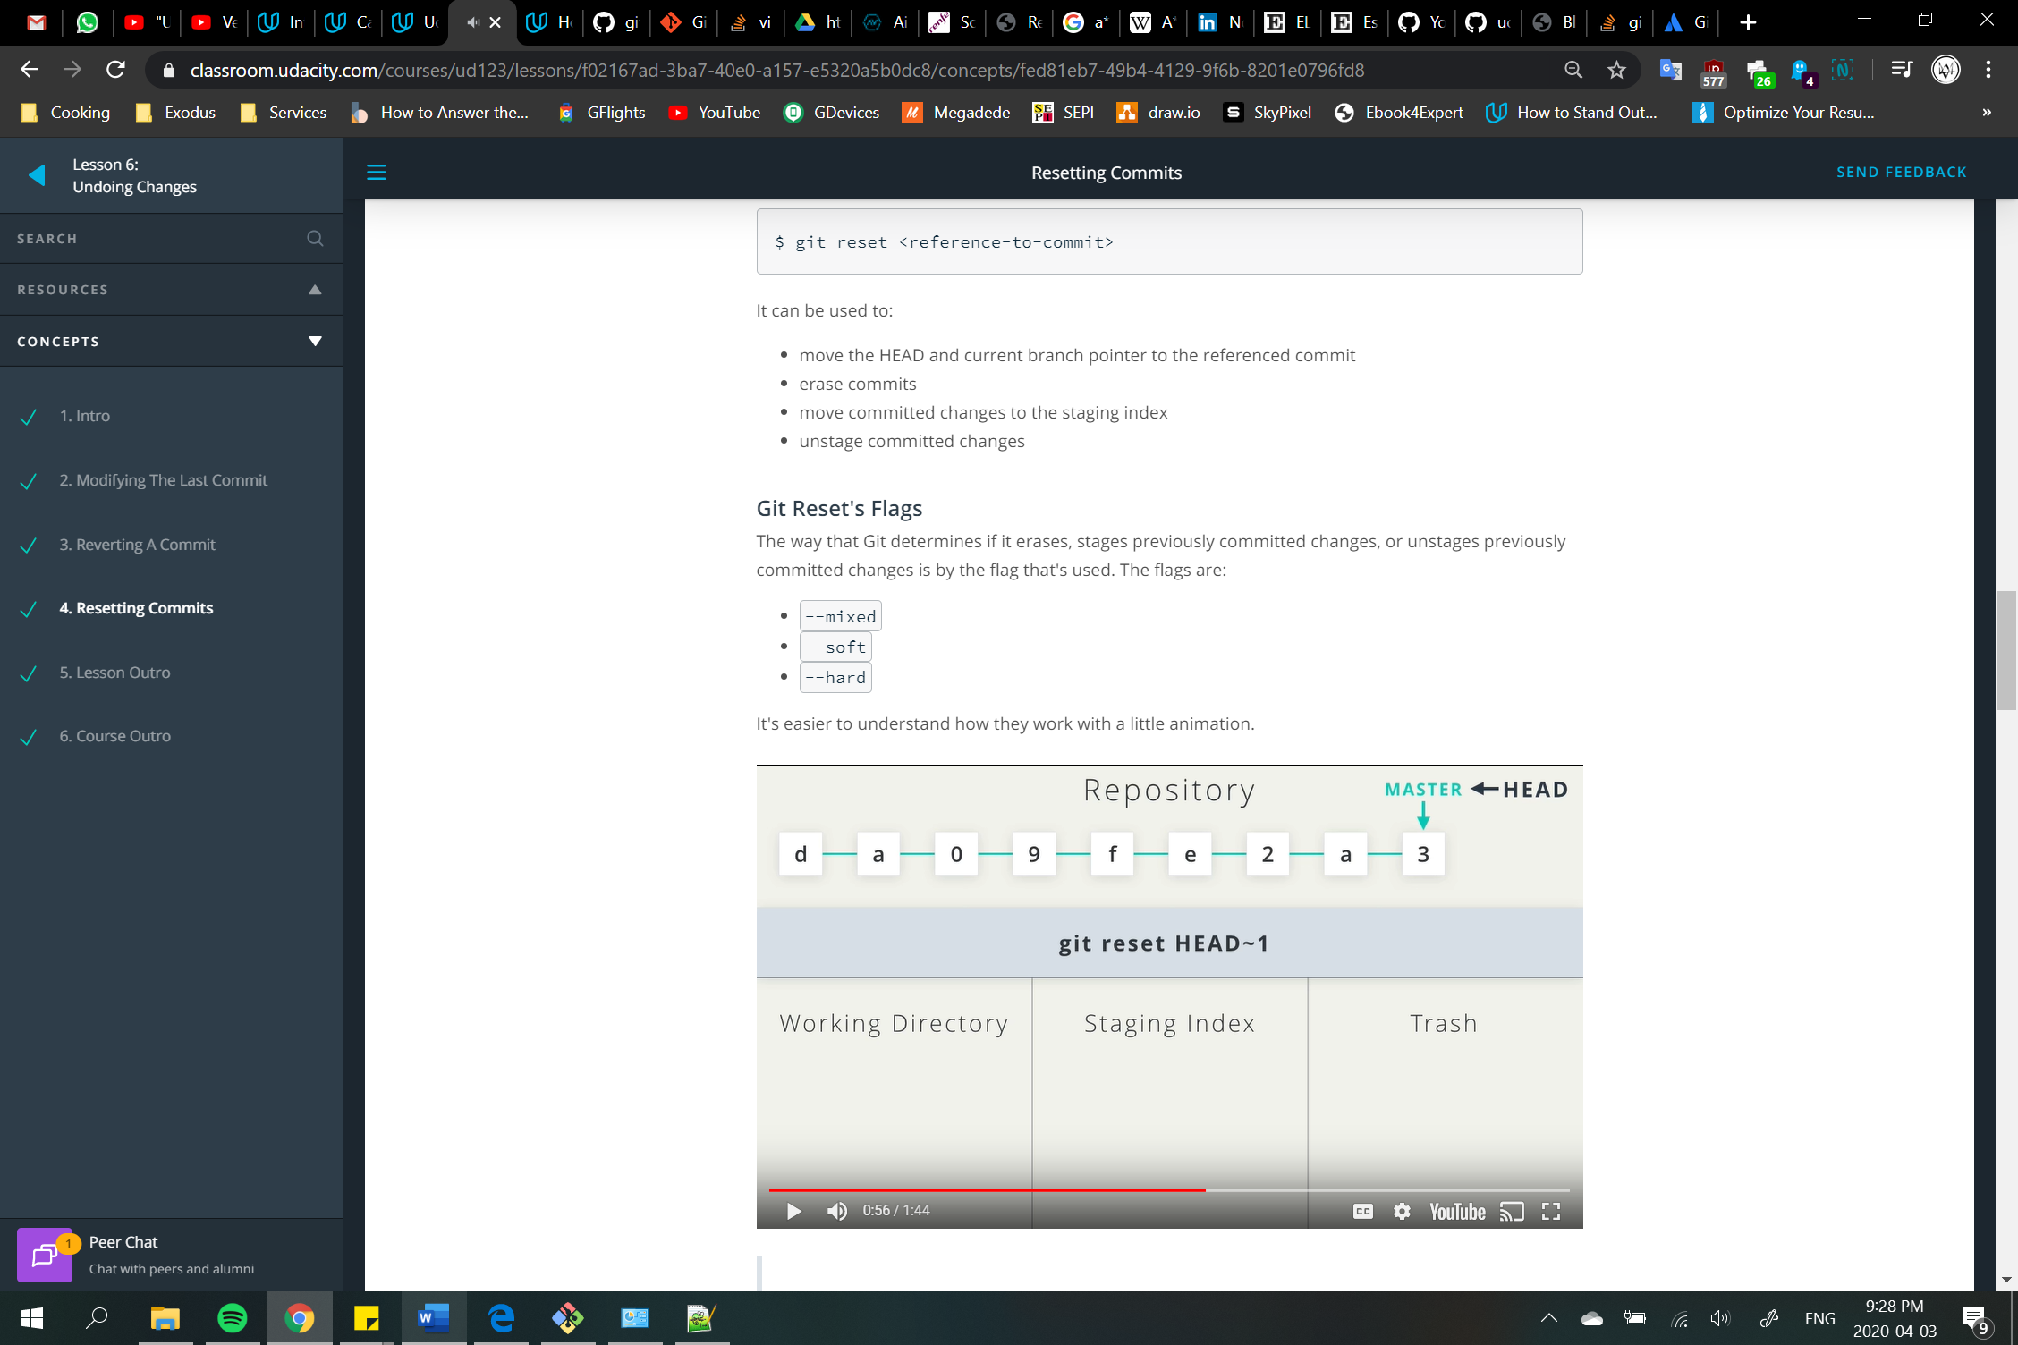 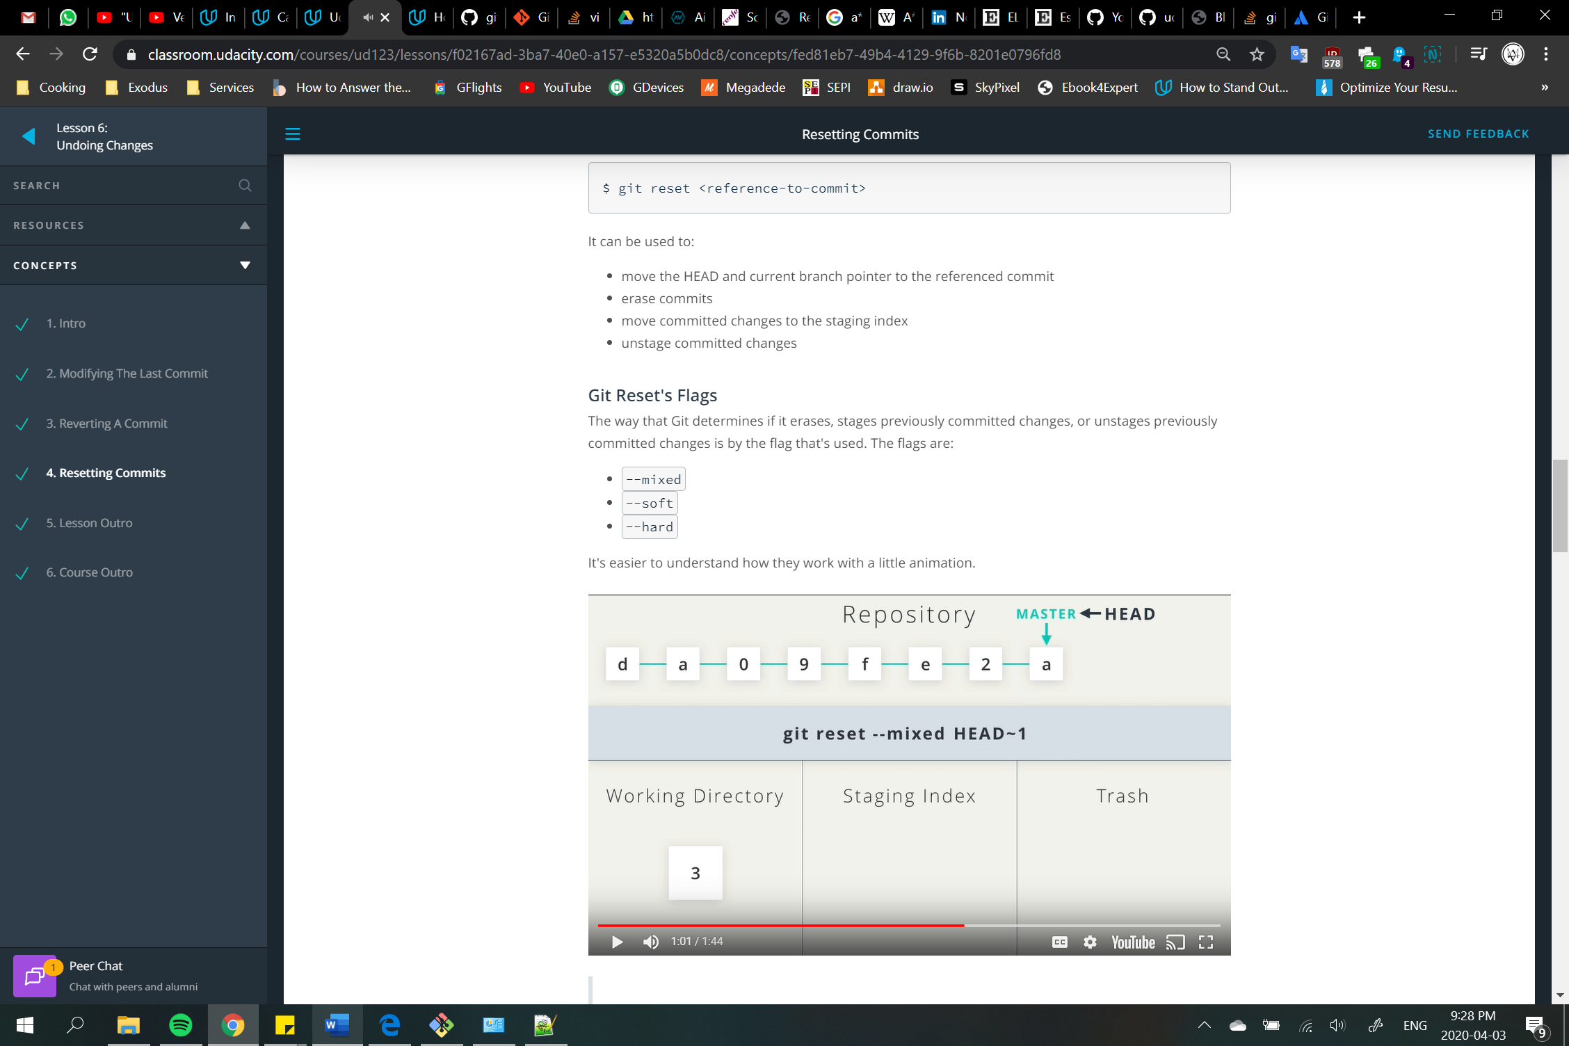

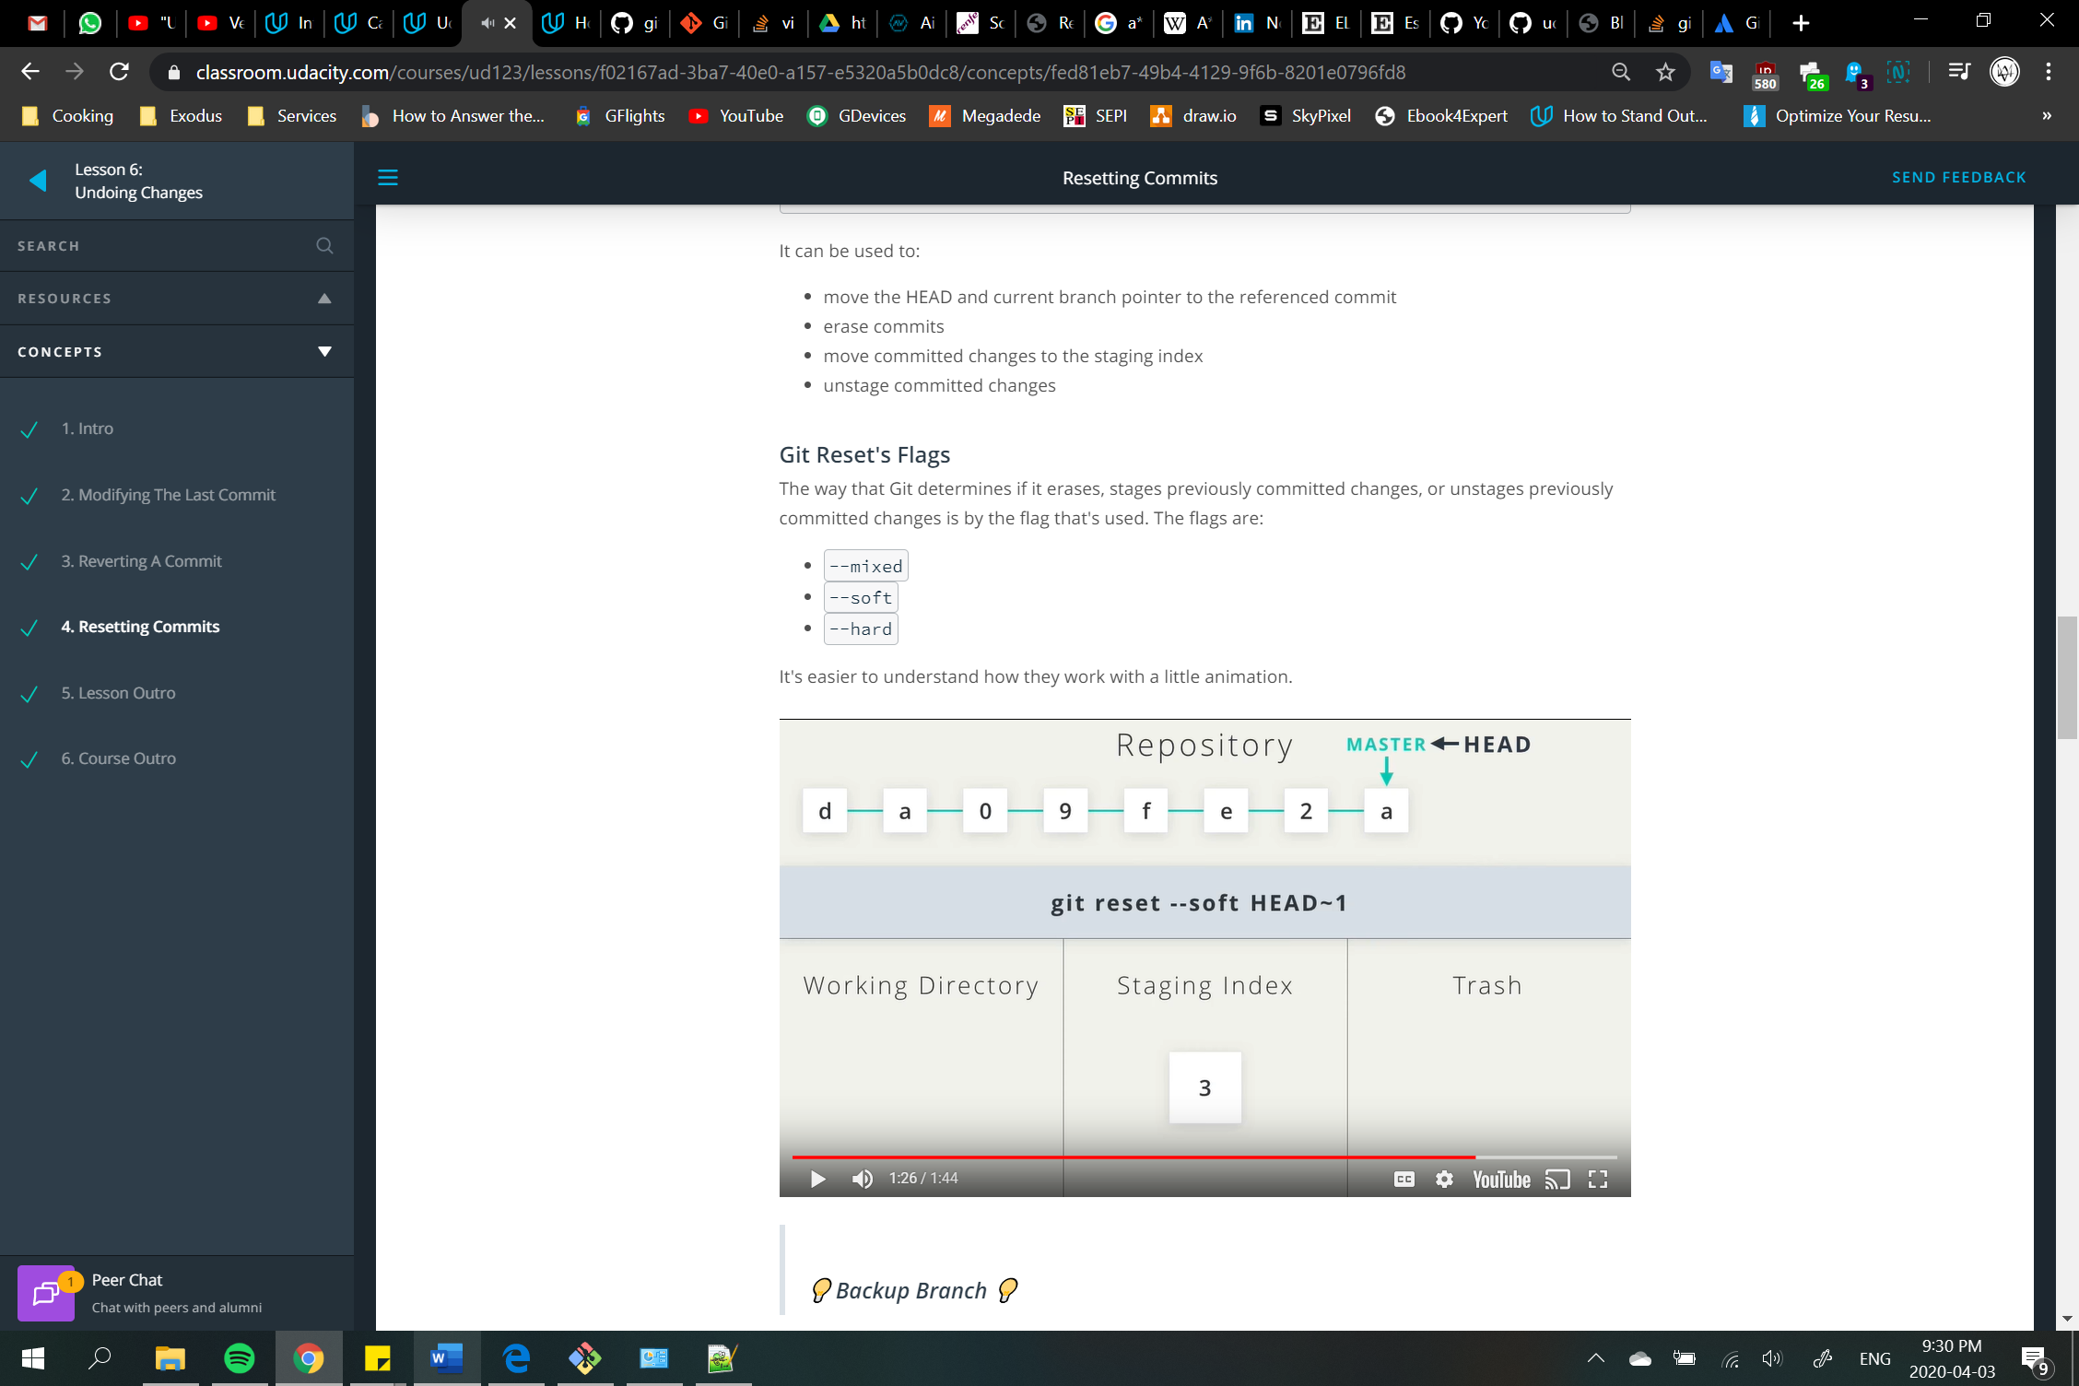 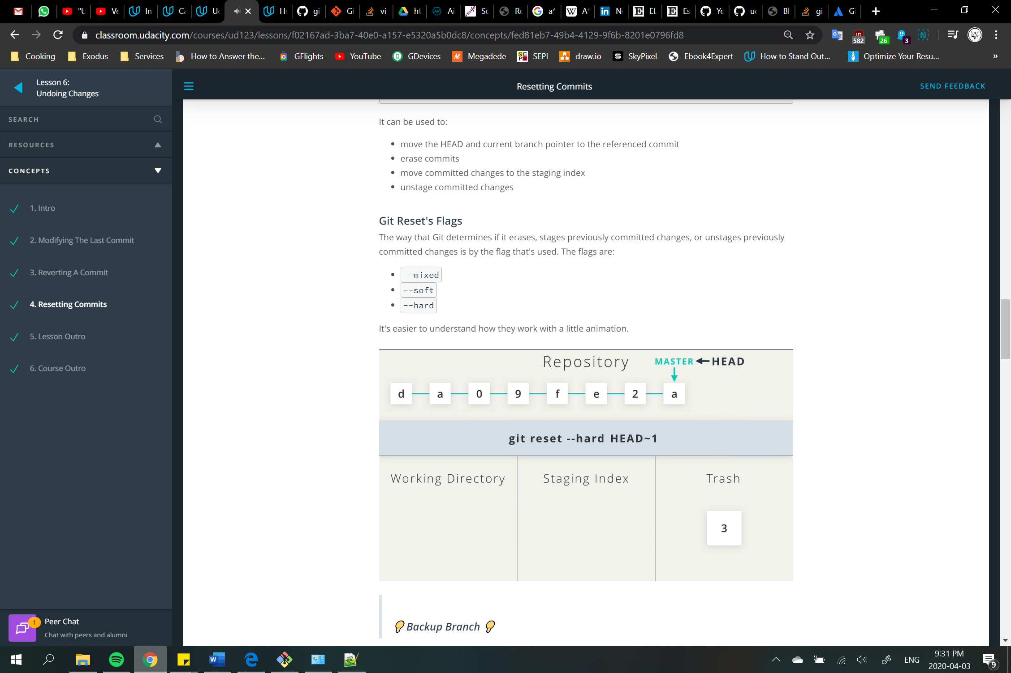

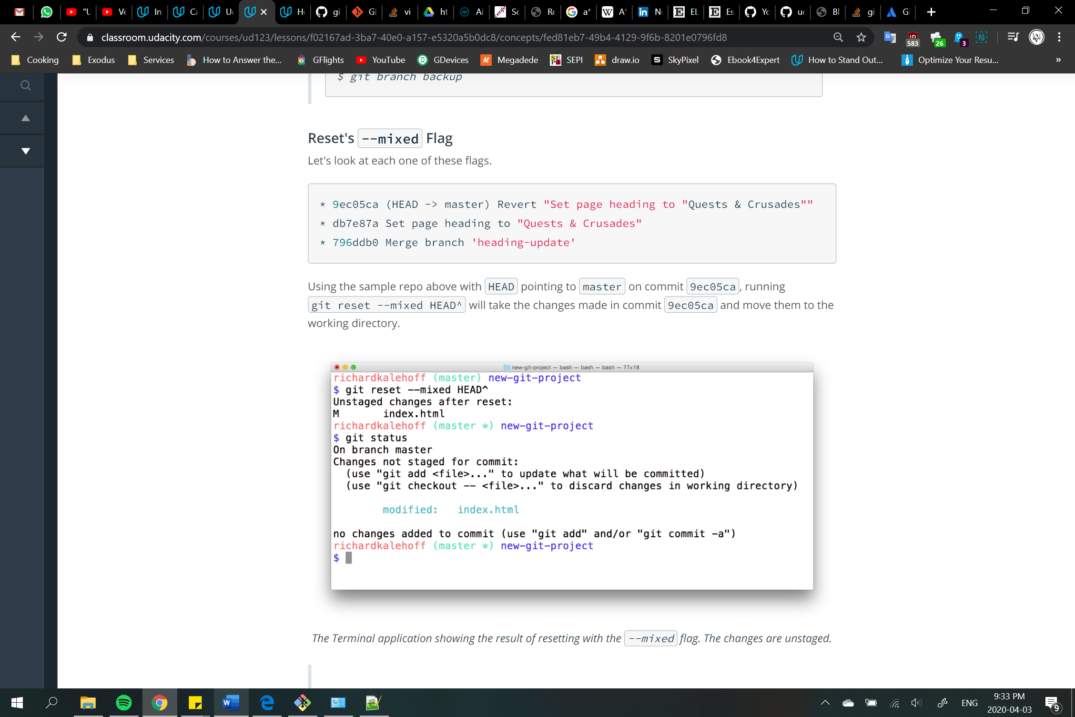

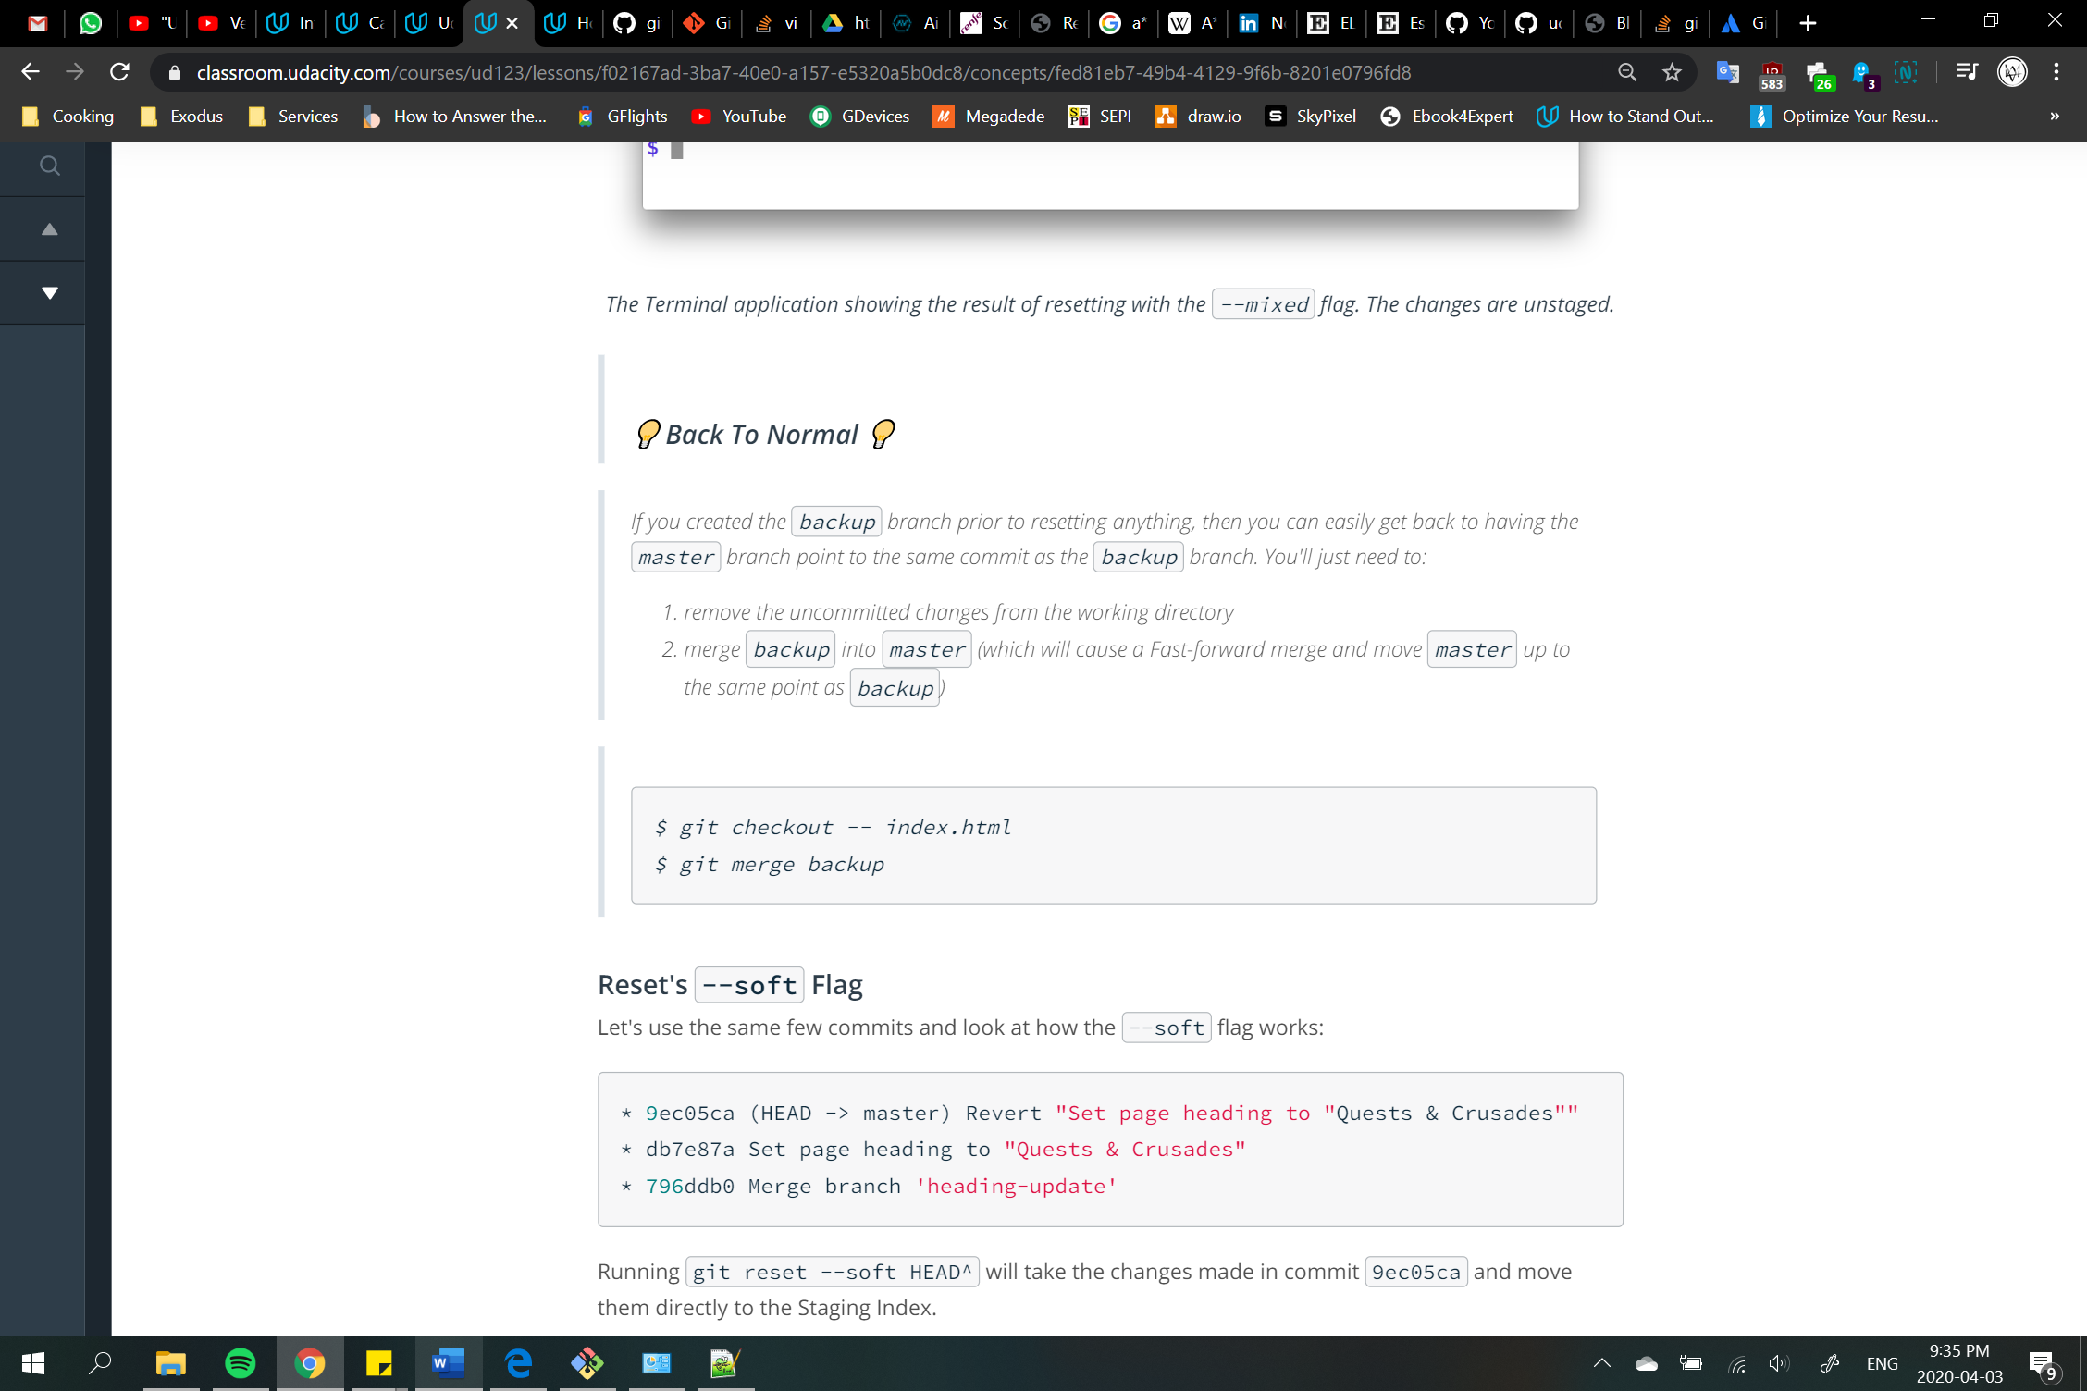

git remote 🡪 interface for managing remote connections you have to other repositories

-v 🡪 includes URL

add <name> <URL>

rename <old name> <new name>

rm <name> 🡪 to remove the connection

git fetch 🡪 downloads commits, files and refs from a remote repository (like update) of all branches

<branch> 🡪 only fetches a branch

--all 🡪 fetches from all registered remotes

--dry-run 🡪 a simulation of a fetch

git fetch vs git pull 🡪 You can consider git fetch the 'safe' version of the two commands. It will download the remote content but not update your local repo's working state, leaving your current work intact. git pull is the more aggressive alternative, it will download the remote content for the active local branch and immediately execute git merge to create a merge commit for the new remote content. If you have pending changes in progress this will cause conflicts and kickoff the merge conflict resolution flow.

git push 🡪 upload your local repository to a remote repository (counterpart of fetch). To prevent you from overwriting commits, Git won’t let you push when it results in a non-fast-forward merge in the destination repository

<remote>

--force 🡪 force push even if it results in a non-fast-forward merge

--all 🡪 push all of your local branches to the specified remote

--tags 🡪 sends all of your local tags to the remote repo since they are not automatically uploaded

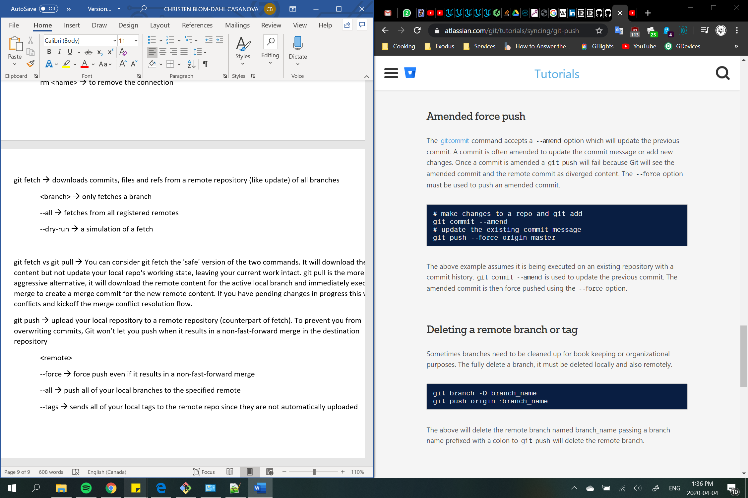

git pull 🡪 used to fetch and download content from a remote repo and immediately update the local repo to match the content [fetch + merge]

<remote>

--rebase

